Corporate Social Investment Platform

By Fifth Year MSc. CA & IT (2022-23)

Group ID: G-48

Roll No: 5078

Name: Sunny Ranjitbhai Vachheta



**Submitted To**

**Prof. Pinal V Padhiyar,**

MSc. Computer Application & Information Technology

K S School of Business Management and Information Technology

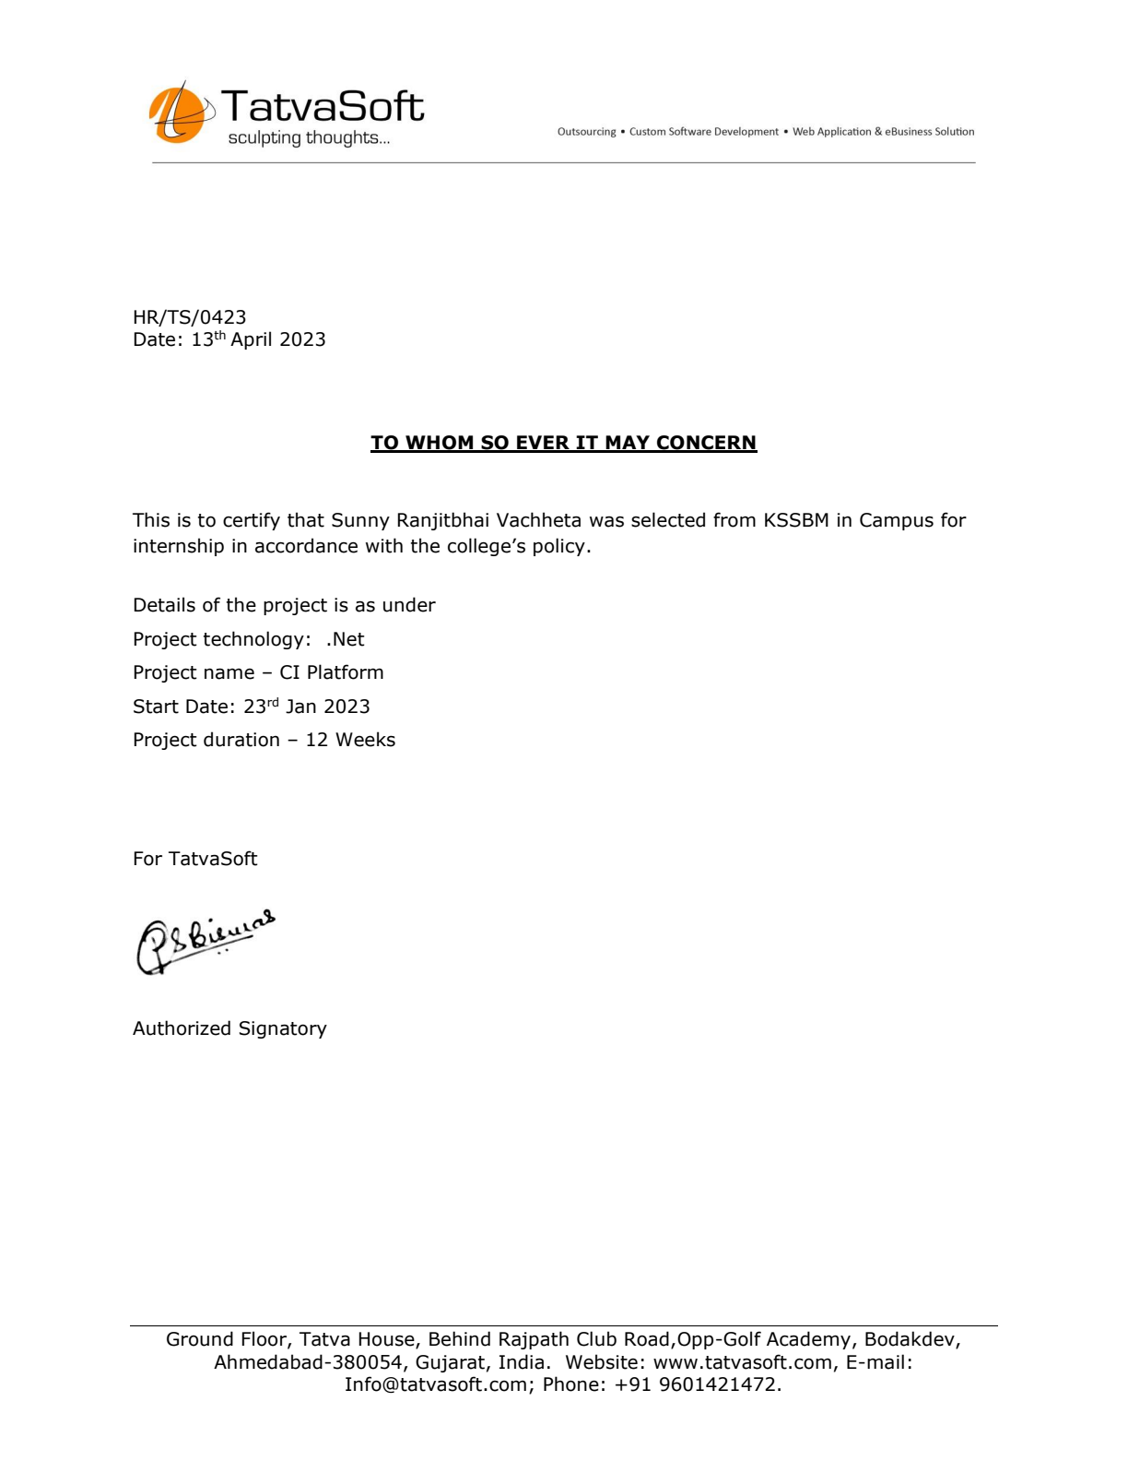

# Index

|  |  |  |  |  |  |
| --- | --- | --- | --- | --- | --- |
| **NO** | **TITLE** | | | | **PAGE NO.** |
| **1** | **INTRODUCTION** | | | | 4 |
|  | 1.1 | Organization Profile | | | 4 |
|  | 1.2 | System Details | | | 5 |
|  |  | 1.2.1 | | Existing System | 5 |
|  |  | 1.2.2 | | Proposed System | 5 |
|  | 1.3 | Scope Of System | | | 6 |
|  | 1.4 | Objectives | | | 6 |
| **2** | **PROPOSED SYSTEM REQUIREMENT GATHERING** | | | | 7 |
|  | 2.1 | Stakeholder Of System | | | 7 |
|  | 2.2 | Requirement Gathering Technique Used | | | 9 |
|  | 2.3 | Consolidated List of Requirement | | | 10 |
|  | 2.4 | Project Definition | | | 10 |
| **3** | **SYSTEM MANAGEMENT AND PLANNING** | | | | 11 |
|  | 3.1 | Feasibility Study | | | 11 |
|  |  | 3.1.1 | | Technical | 11 |
|  |  | 3.1.2 | | Economical | 12 |
|  |  | 3.1.3 | | Operational | 12 |
|  | 3.2 | Hardware – Software Requirement | | | 13 |
|  | 3.3 | System Planning | | | 14 |
|  |  | 3.3.1 | | Work Breakdown Structure | 14 |
|  |  | 3.3.2 | | Gantt Chart | 16 |
|  | 3.4 | Process Model | | | 17 |
| **4** | **SYSTEM ANALYSIS AND DESIGN** | | | | 19 |
|  | 4.1 | UML (Unified Modeling Language) | | | 19 |
|  |  | 4.1.1 | | Use Case | 20 |
|  |  | 4.1.2 | | Activity Diagram | 20 |
|  |  | 4.1.3 | | Class Diagram | 22 |
|  | 4.2 | System Flow Diagram | | | 27 |
|  | 4.3 | Data Dictionary | | | 30 |
|  | 4.4 | System Navigation | | | 37 |
| **5** | **Input/Output Design** | | | | 38 |
| **6** | **Testing** | | | | 58 |
| **7** | **Summary** | | | | 68 |
|  | 7.1 | | Assumptions | | 68 |
|  | 7.2 | | Limitations | | 68 |
|  | 7.3 | | Future Scope | | 68 |
|  | 7.4 | | Conclusion | | 68 |
| **8** | **Bibliography** | | | | 69 |

**1. Introduction**

The platform will allow the company to “plan and manage effort that seeks to motivate and enable employees to effectively serve community needs through the leadership of the employer.”

**CI (Community investment / corporate social investment / Community social investment) platform** can also be called employee volunteer program, workplace volunteer programs, corporate volunteer programs, company volunteer programs, and other iterations. These programs are typically built to support a company’s larger corporate social responsibility program (CSR) or community engagement program or community investment program. Companies may have specific reasoning for building such platforms like building a positive brand reputation or increasing employee engagement in the community.

**1.1 Organization Profile**

**TatvaSoft**

TatvaSoft House,  
Rajpath Club Road,  
Ahmedabad, Gujarat, 380054

[www.tatvasoft.com](http://www.tatvasoft.com/)

Tatvasoft is CMMi maturity level 3 company established in 2001. Tatvasoft is a custom software development company delivering business splendid IT solutions and related services to customers across the globe.

Tatvasoft has successfully served for more than 1800 success stories ranging from enterprise level to startups, who have grown alongside the success of the company.

Tatvasoft has more than 21+ years of technology experience engaging with customers at deeper level to provide cutting edge solutions and innovations.

**1.2 System Details**

**1.2.1 Existing System**

* Volunteer Management: Corporations would manage volunteer programs manually, using spreadsheets or other manual tools. They would manually track volunteer hours, coordinate volunteer events, and communicate with volunteers.
* Employee Engagement: Corporations would rely on manual communication methods, such as meetings and memos, to encourage employee engagement in CSI initiatives. They may use manual methods, such as collection boxes or paper forms, to collect employee application.
* Corporations would manually compile and analyze data on their CSI initiatives, using spreadsheets, reports, and other manual tools. They would manually track the impact of their initiatives and make decisions based on this data.

**1.2.2 Proposed System**

* Employee Engagement: The website could also be used to engage employees in CSI initiatives. This could include features such as employee volunteering programs and fundraising events. Employees could log their volunteer hours and fundraising efforts on the website, creating a sense of community and encouraging others to get involved.
* Reporting and Analytics: The website could provide detailed reporting and analytics on the company's CSI initiatives. This could include information on the amount of money donated, the impact of the initiatives, and the effectiveness of different programs. The data could be used to improve the company's CSI strategy and identify areas for improvement.
* Volunteers who took part in missions can share their experience to show the impact of company’s initiatives effectiveness on society and encourage others to take part in missions.

**1.3 Scope of System**

* User Registration and Management: The platform will allow users to register and create their profiles, which can be updated or deleted as required.
* Mission Management: The platform will enable admin to create and manage social projects, including their objectives, contribution, registration, timelines, and outcomes.
* Collaboration and Networking: The platform will facilitate collaboration and networking among users, enabling them to share practices, ideas, and resources through their stories.
* Marketing and Promotion: The platform will be marketed and promoted to attract users, including through social media, email marketing, and other digital channels.
* Report and Analysis: The platform allows the admin to get current information about their missions, users, queries, initiatives and their progress.

**1.4 Objectives:**

* CSI platform will be used to maintaining all CI related records in organized manner.
* Promoting social development.
* Collaboration and networking.
* Enhance brand reputation
* Creating sustainable impact
* Managing missions
* Volunteer engagement

**2.1 Proposed System Requirement Gathering**

**2.1.1 Stakeholder of the system**

1) Admin

2) Volunteers

3) Visitors

**1) Admin**

* Login
* Manage missions
* Manage initiatives
* Manage volunteer stories
* CMS
* Mission theme
* Mission skills
* Mission applications
* Banner management
* Volunteer time-sheet management
* Manage different types of missions
* Manage user queries

**2) Volunteers:**

* Registration & Login
* Forgot password
* Edit profile
* Participate as volunteer in mission's
* Rating
* Comments
* Add to favourites
* Share your story
* Time-sheet management
* Recommend mission to co-workers
* Recommend story to co-workers
* Send query to admin

**3) Visitors:**

* View missions
* View stories
* View Feedback
* View rating
* View mission details

**2.2.2 Requirement Gathering Techniques Used**

There are many techniques to gather information about system requirements such as:

1. Examining Documentation
2. Interviewing
3. Observation
4. Research
5. Prototyping
6. Questionnaire

Here we use Questionnaires and Observation techniques to gather requirements of our System. Questionnaires are much more informal and it is good technique to gather requirements from stakeholder in remote location or those who will have only minor input of the overall requirements. With using Questionnaires, we get following questions and answers:

* **Questionnaire asked to admin:**

1. Why you want to digitalize your system?
2. Is there any web-based system for your organization?
3. Where would the user access this system?
4. What is the problem in current system?
5. What functionality do you want in proposed system?
6. Why are you moving on web to manage your system?
7. What is your ultimate vision to moving on digital platform?

* **Questionnaire asked to employee(volunteer):**

1. Which feature do you want to have in the system?
2. When you are going to use the system?
3. Is this system will be helpful?
4. When you will not like the system?
5. What are the current problems you are facing without web application?

**2.3 Consolidated List of Requirement**

* Admin can manage overall website and volunteer database.
* Admin can manage registered volunteers, stories and missions.
* Admin can track mission progression.
* Manages volunteer time-sheet.
* Manages mission themes and skills.
* Content management pages.
* Manages contact queries.
* Banner management.
* User stories management by admin.
* User can register and login in web-application.
* User can edit his/her profile.
* Add/Remove skills.
* Sending and receiving recommendation via e-mail.
* In order to participate as volunteer, requires login.
* Collaboration and networking with share stories.
* Add missions to their favourite.
* Ask queries to admin using contact-us.

**2.4 Project Definition:**

Corporate Social Investment Platform

The platform will allow the company to plan and manage effort that seeks to motivate and enable employees to effectively serve community needs through the leadership of the employer. This platform will support larger companies corporate social responsibility. Companies may have specific reasoning for building such platforms like building a positive brand reputation or increasing employee engagement in the community.

**3. System Management and Planning**

**3.1 Feasibility Study**

A feasibility study is carried out to select the best system that meets performance requirements. The main aim of the feasibility study is to determine that it would be financially and technically feasible to develop the product or not. The purpose of feasibility study is not to solve the problem, but to determine whether the problem is worth solving.

**3.1.1 Technical feasibility**

Technical feasibility study compares the level of technology available in the software development firm and the level of technology required for the development of the product. Here the technology consists of programming language, hardware resources and other software tools.

**Why our system is technically feasible?**

* Our system just requires window operating system, normal browser and Internet.
* It is web-based user interface. Thus, it provides an easy access to the user.
* No special hardware or software is required.
* There is no need to purchase any type of server so that all data that are needed to running system available there.
* The system is stable and established, resources are easily available /accessible and also expertise is available.

**3.1.2 Economical Feasibility:**

Economical feasibility study evaluates the cost of the software development against the ultimate income or benefits gets from the developed system. There must be scope for profit after the successful completion of the project.

**Why our system is economically feasible?**

* As there is no paperwork required so it reduce the cost of working it manually.
* High increase in the amount of effectiveness earned by going global.
* All people are aware of new technology so there is no problem to run the system and no special skills are required.
* Only one-time development is required for this kind of system and if we want to expand it in future no more extra investment needed.
* Easy and cheap maintenance of the system.
* So that this system is economically feasible.

**3.1.3 Operational feasibility:**

Operational feasibility is a measure of how well a proposed system solves the problems, take advantages of the opportunities identified during the scope of definition and how it satisfies the requirements identified in the requirements analysis phase of system development.

**Why our system is operationally feasible?**

1. Our system is developed in such a way that would be easy to understand and operate.
2. The system interface is standard, user friendly and provides extensive help.
3. No special training is required.
4. System will be able to solve the business-related problem and satisfy user requirements.
5. User friendly GUI.
6. So, the system is operationally feasible.

**3.2 Hardware – Software requirement:**

* **Hardware requirement**

Server side requirements

|  |  |
| --- | --- |
| Processor | Minimum Core i3 |
| RAM | 4 GB |
| Hard Disk | 512 GB |

Client side requirements

|  |  |
| --- | --- |
| Processor | Minimum Core i3 |
| RAM | 1 GB |

* **Software Requirement**

Server side requirements

|  |  |
| --- | --- |
| Operating System | Windows |
| Web Server | IIS Express |
| Database | SQL Server |

Client side requirements

|  |  |
| --- | --- |
| Operating System | Any |
| Web Browser | Chrome, Firefox, Edge, Safari, Opera |

**3.3 System Planning**

**3.3.1 Work Breakdown Structure**

* Dividing complex projects to simpler and manageable tasks is the process identified as Work Breakdown Structure.
* Usually, the project managers use this method for simplifying the project execution.
* In WBS, much larger tasks are broke down to manageable chunks of work. These chunks can be easily supervised and estimated.
* Following are a few reasons for creating a WBS in a project:
  + Accurate and readable project organization.
  + Accurate assignment of responsibilities to the project team.
  + Indicates the project milestones and control points.
  + Useful for estimating the cost, time and risk.
  + Illustrate the project scope, so the stakeholder can have a better understanding of the same.

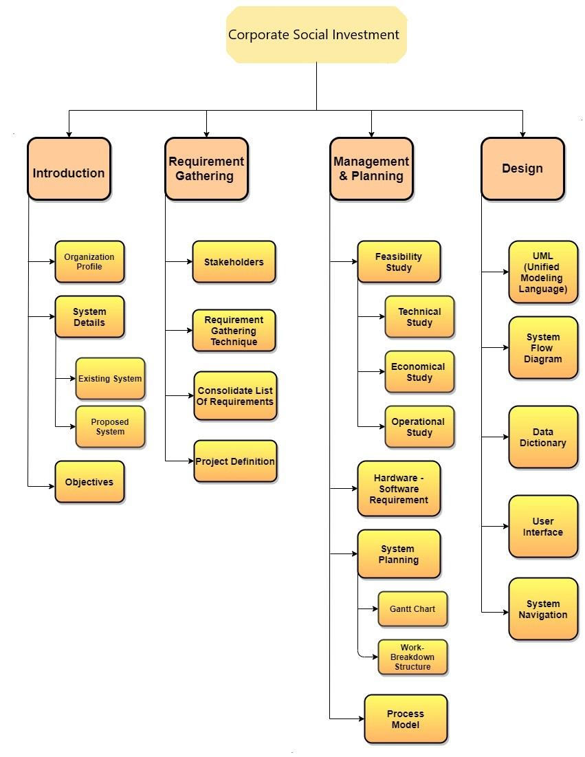

**3.3.2 Gantt Chart**

1. Gantt chart is a type of a bar chart that is used for illustrating project schedules. Gantt charts can be used in any projects that involve effort, resources, milestones and deliveries.
2. At present, Gantt charts have become the popular choice of project managers in every field. Gantt charts allow project managers to track the progress of the entire project. Through Gantt charts, the project manager can keep a track of the individual tasks as well as of the overall project progression.
3. In addition to tracking the progression of the tasks, Gantt charts can also be used for tracking the utilization of the resources in the project.

|  |  |  |  |  |  |  |  |
| --- | --- | --- | --- | --- | --- | --- | --- |
| ID | Task Name | February | | March | | | April |
| 1 | Project Scope |  |  |  | | |  |
| 2 | Requirement Gathering |  |  |  |  | |  |
| 3 | Analysis |  |  |  | |  |  |
| 4 | Design |  | |  |  | |  |

**3.4 Process Model**

**Incremental Model:**

As new requirements can arise in future incremental models are used. With the help of it we can fulfil maximum user requirements. In every increment the needs of the client are kept in mind and more features and functions are added. These increments form a base for customer evaluation. Many features can be added after the development of the system that serves the main purpose. If there is a smaller number of employees to work on the project Incremental development model is very useful to complete the project before the deadline.

* **Advantages:**

1. This model is more flexible – less costly to change scope and requirements.
2. It is easier to test and debug during a smaller iteration.
3. In this model customer can respond to each built.
4. Lowers initial delivery cost.
5. This process model helps to manage technical risks.
6. Initial product delivery is faster.
7. Work load is less.
8. Customer can respond to feature and review the product.
9. Risk of changing requirement is reduced.
10. Core product is developed first that is main functionality is added in the first increment.

* **Disadvantages:**

1. Requires good analysis.
2. Resulting cost may exceed the cost of the organization.
3. Each phase of iteration is rigid and not overlaps each other.
4. As additional functionality is added to the product, problems may arise related to systems.
5. May arise related to system architecture which were not evident in earlier prototypes.

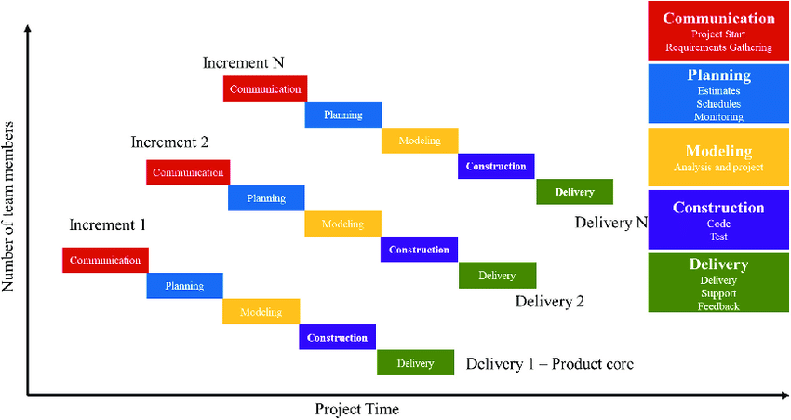

**4. System Analysis and Design**

**4.1 UML**

**4.1.1 Use Cases**

* Visitor

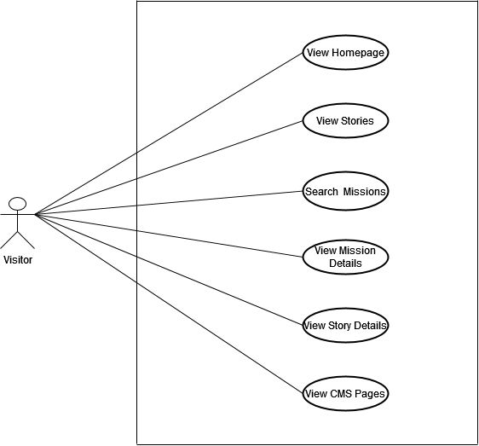

* Admin

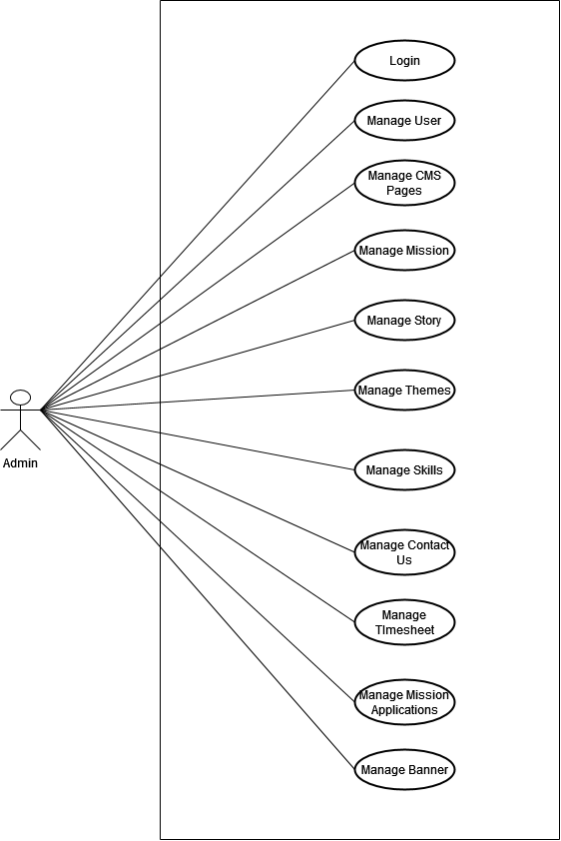

* User

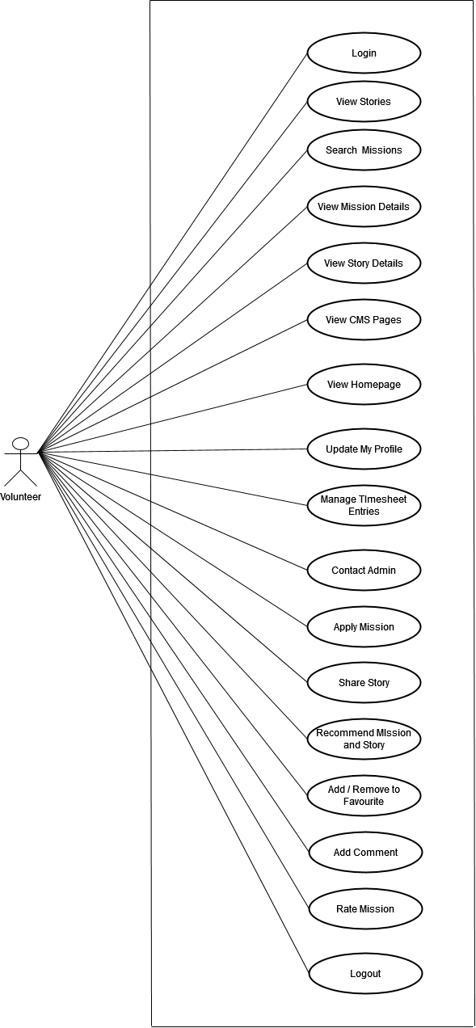

4.1.2 Activity Diagram

* Admin

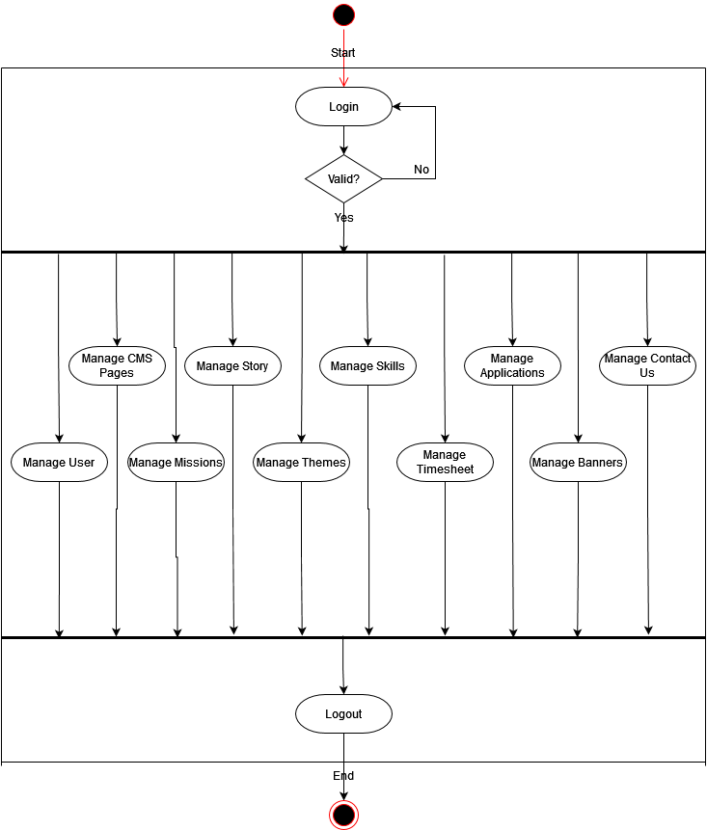

* User

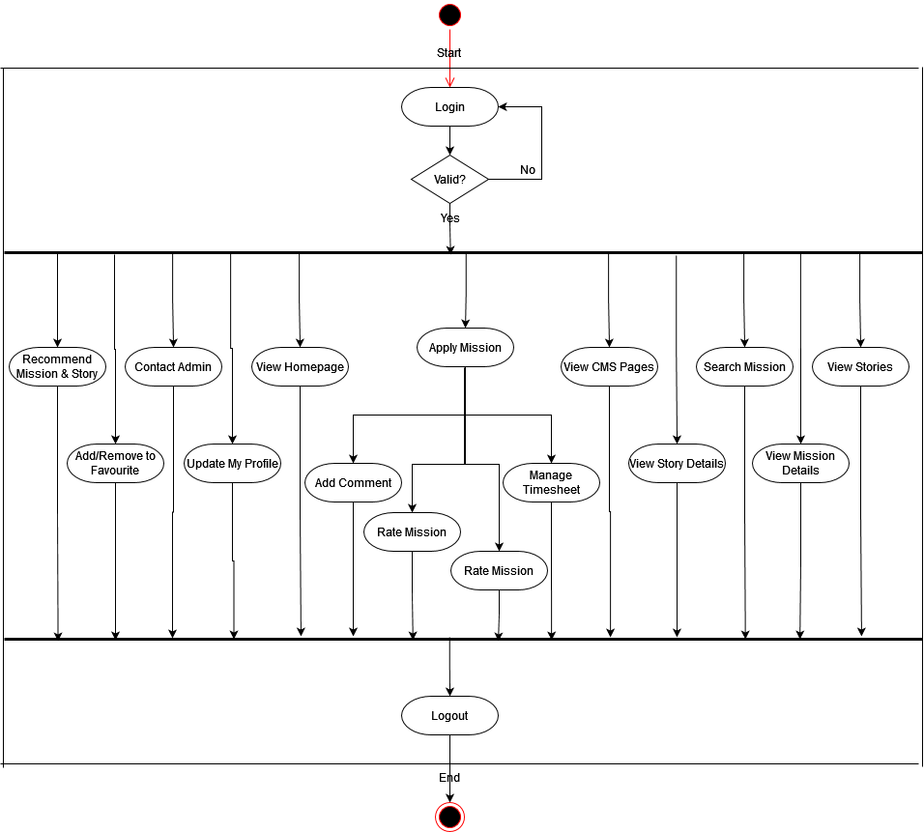

* Visitor

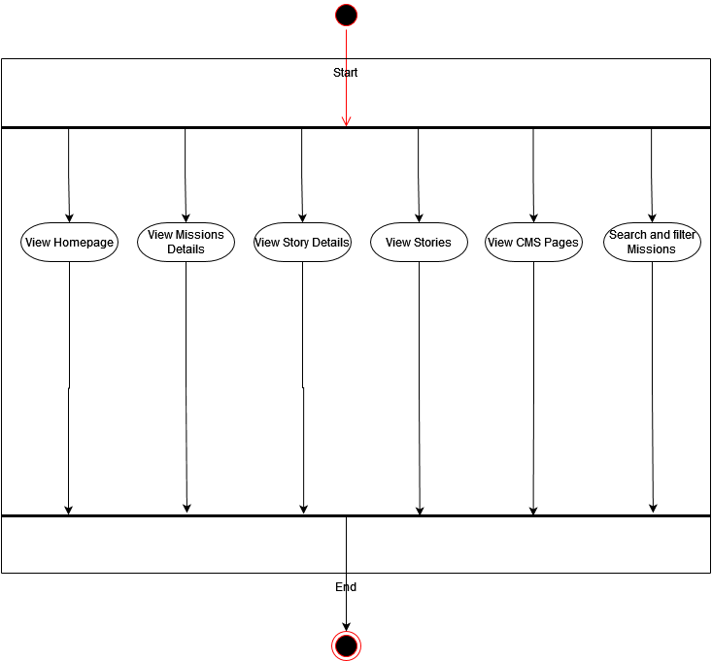

4.1.3 Class Diagram



**4.2 System Flow Diagram**

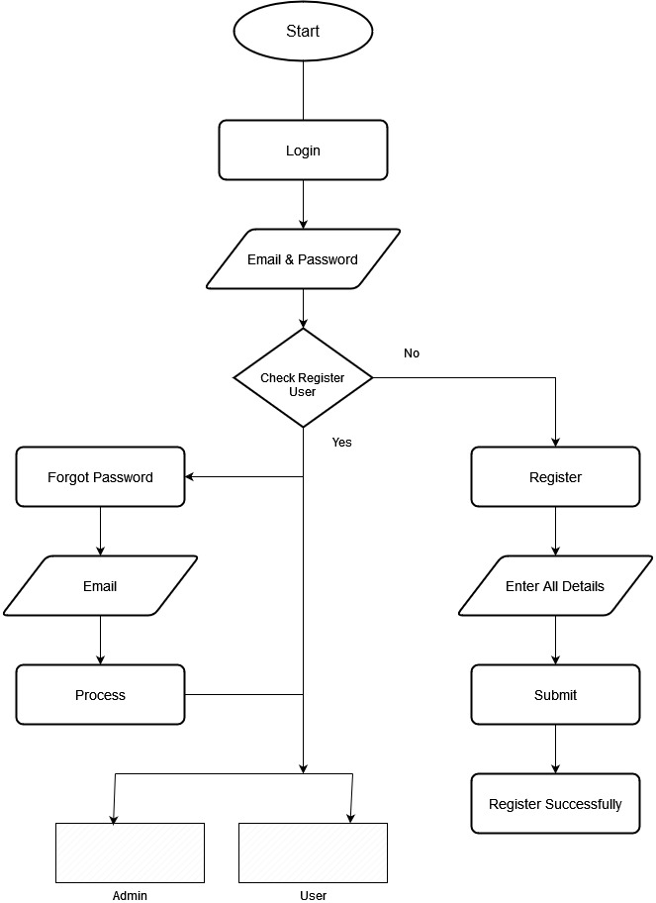

* Admin

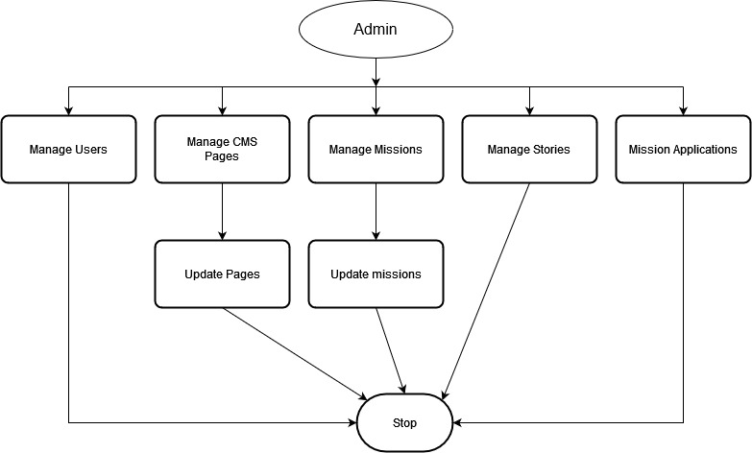

* User flow

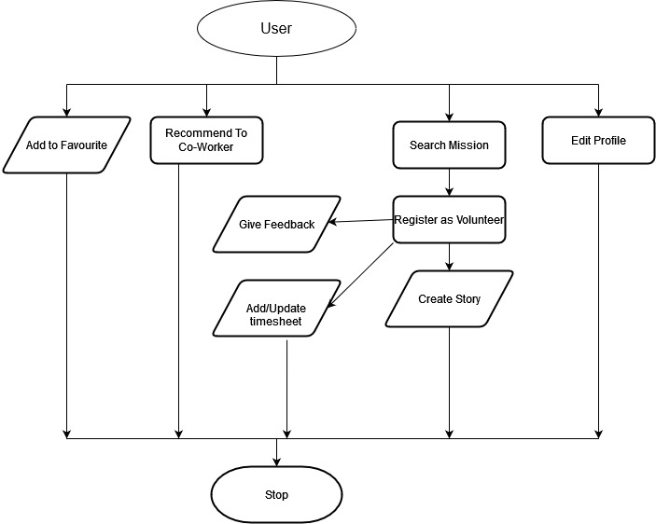

**4.3 Data Dictionary**

1) User

|  |  |  |  |  |  |  |  |
| --- | --- | --- | --- | --- | --- | --- | --- |
| **Field** | **Type** | **Size** | **NULL** | **DEFUALT** | **EXTRA** | **ATTRIBUTE** | **KEY** |
| ***user_id*** | ***bigint*** | ***20*** | ***NO*** | ***None*** | ***AUTO INCREMENT*** | ***Unsigned*** | ***Primary Key*** |
| first name | varchar | 16 | No |  |  |  |  |
| last name | varchar | 16 | No |  |  |  |  |
| email | varchar | 128 | No | None |  |  | Unique Key |
| password | varchar | 255 | No | None |  |  |  |
| avatar | varchar | 2048 | Yes | NULL |  |  |  |
| department | varchar | 16 | Yes | NULL |  |  |  |
| employee_id | varchar | 16 | Yes | NULL |  |  |  |
| ***city_id*** | ***bigint*** | ***20*** | ***No*** | ***None*** |  | ***Unsigned*** | ***FK(city.city_id)*** |
| ***country_id*** | ***bigint*** | ***20*** | ***No*** | ***None*** |  | ***Unsigned*** | ***FK(country.country_id)*** |
| profile_text | text |  | Yes | NULL |  |  |  |
| status | bit |  | No | 1 |  |  |  |
| phone_number | int | 11 | No | None |  |  |  |
| why_i_volunteer | text |  | Yes | NULL |  |  |  |
| linked_in_url | varchar | 255 | Yes | NULL |  |  |  |
| title | varchar | 255 | Yes | NULL |  |  |  |
| created_at | timestamp |  | No | CURRENT_TIMESTAMP |  |  |  |
| updated_at | timestamp |  | Yes | NULL |  |  |  |
| deleted_at | timestamp |  | Yes | NULL |  |  |  |

2) Admin

|  |  |  |  |  |  |  |  |
| --- | --- | --- | --- | --- | --- | --- | --- |
| **Field** | **Type** | **Size** | **NULL** | **DEFUALT** | **EXTRA** | **ATTRIBUTE** | **KEY** |
| ***admin_id*** | ***tinyint*** | ***1*** | ***NO*** | ***None*** | ***AUTO INCREMENT*** | ***Unsigned*** | ***Primary Key*** |
| first name | varchar | 16 | Yes | NULL |  |  |  |
| last name | varchar | 16 | Yes | NULL |  |  |  |
| email | varchar | 128 | No | None |  |  | Unique Key |
| password | varchar | 255 | No | None |  |  |  |
| created_at | timestamp |  | No | CURRENT_TIMESTAMP |  |  |  |
| updated_at | timestamp |  | Yes | NULL |  |  |  |
| deleted_at | timestamp |  | Yes | NULL |  |  |  |

3) Country

|  |  |  |  |  |  |  |  |
| --- | --- | --- | --- | --- | --- | --- | --- |
| **Field** | **Type** | **Size** | **NULL** | **DEFUALT** | **EXTRA** | **ATTRIBUTE** | **KEY** |
| ***country_id*** | ***TINYINT*** | ***1*** | ***No*** | ***None*** | ***AUTO INCREMENT*** | ***Unsigned*** | ***Primary Key*** |
| country_name | varchar | 30 | No | None |  |  | Unique Key |
| ISO | varchar | 16 | Yes | None |  |  |  |
| created_at | timestamp |  | No | CURRENT_TIMESTAMP |  |  |  |
| updated_at | timestamp |  | Yes | Null |  |  |  |
| deleted_at | timestamp |  | Yes | Null |  |  |  |

3) City

|  |  |  |  |  |  |  |  |
| --- | --- | --- | --- | --- | --- | --- | --- |
| **Field** | **Type** | **Size** | **NULL** | **DEFUALT** | **EXTRA** | **ATTRIBUTE** | **KEY** |
| ***city_id*** | ***SMALLINT*** | ***2*** | ***No*** | ***None*** | ***AUTO INCREMENT*** | ***Unsigned*** | ***Primary Key*** |
| ***country_id*** | ***TINYINT*** | ***1*** | ***No*** | ***None*** | ***AUTO INCREMENT*** | ***Unsigned*** | ***FK(country.country_id)*** |
| city_name | varchar | 30 | No | None |  |  | Unique Key |
| created_at | timestamp |  | No | CURRENT_TIMESTAMP |  |  |  |
| updated_at | timestamp |  | Yes | Null |  |  |  |
| deleted_at | timestamp |  | Yes | Null |  |  |  |

4) CMS Page

|  |  |  |  |  |  |  |  |
| --- | --- | --- | --- | --- | --- | --- | --- |
| **Field** | **Type** | **Size** | **NULL** | **DEFUALT** | **EXTRA** | **ATTRIBUTE** | **KEY** |
| ***cms_page_id*** | ***smallint*** | ***2*** | ***No*** | ***None*** | ***AUTO INCREMENT*** | ***Unsigned*** | ***Primary Key*** |
| page_title | varchar | 255 | Yes | NULL |  |  |  |
| page_description | text |  | Yes | NULL |  |  |  |
| slug | varchar | 255 | Yes | NULL |  |  | Unique key |
| status | bit | 0,1 | No | 1 |  |  |  |
| created_at | timestamp |  | No | CURRENT_TIMESTAMP |  |  |  |
| updated_at | timestamp |  | Yes | NULL |  |  |  |
| deleted_at | timestamp |  | Yes | NULL |  |  |  |

5) Skill

|  |  |  |  |  |  |  |  |
| --- | --- | --- | --- | --- | --- | --- | --- |
| **Field** | **Type** | **Size** | **NULL** | **DEFUALT** | **EXTRA** | **ATTRIBUTE** | **KEY** |
| ***skill_id*** | ***int*** | ***11*** | ***No*** | ***None*** | ***AUTO INCREMENT*** | ***Unsigned*** | ***Primary Key*** |
| skill_name | varchar | 64 | No | None |  |  | Unique Key |
| skill_name | varchar | 64 |  |  |  |  |  |
| status | tinyint | 1 | No | 1 |  |  |  |
| created_at | timestamp |  | No | CURRENT_TIMESTAMP |  |  |  |
| updated_at | timestamp |  | Yes | Null |  |  |  |
| deleted_at | timestamp |  | Yes | Null |  |  |  |

6) Mission

|  |  |  |  |  |  |  |  |  |
| --- | --- | --- | --- | --- | --- | --- | --- | --- |
| **Field** | **Type** | **Size** | **NULL** | **DEFUALT** | **EXTRA** | **ATTRIBUTE** | **KEY** |  |
| ***mission_id*** | ***bigint*** | ***20*** | ***No*** | ***None*** | ***AUTO INCREMENT*** | ***Unsigned*** | ***Primary Key*** |  |
| mission_title | varchar | 128 | Yes | Null |  |  |  |  |
| short_description | text |  | Yes | Null |  |  |  |  |
| description | text |  | Yes | Null |  |  |  |  |
| ***city_id*** | ***smallint*** | ***2*** | ***No*** | ***None*** |  | ***Unsigned*** | ***FK(city.city_id)*** |  |
| ***country_id*** | ***tinyint*** | ***1*** | ***No*** | ***None*** |  | ***Unsigned*** | ***FK(country.country_id)*** |  |
| organization_name | varchar | 20 | Yes | Null |  |  |  |  |
| organization_details | text |  | Yes | Null |  |  |  |  |
| start_date | datetimeoffset |  | Yes | Null |  |  |  |  |
| end_date | datetimeoffset |  | Yes | Null |  |  |  |  |
| mission_type | enum | TIME, GOAL | No | None |  |  |  |  |
| total_seats | bigint | 20 | Yes | Null |  | ***Unsigned*** |  |  |
| registration_deadline | datetimeoffset |  | Yes | Null |  |  |  |  |
| ***theme_id*** | ***smallint*** | ***2*** | ***No*** | ***None*** |  | ***Unsigned*** | ***FK(mission_theme.theme_id)*** |  |
| availability | enum | daily, weekly, week-end, monthly | Yes | Null |  |  |  |  |
| created_at | timestamp |  | No | CURRENT_TIMESTAMP |  |  |  |  |
| updated_at | timestamp |  | Yes | NULL |  |  |  |  |
| deleted_at | timestamp |  | Yes | NULL |  |  |  |  |
| status | enum | 0,1 |  |  |  |  |  |  |

7) Mission Skill

|  |  |  |  |  |  |  |  |
| --- | --- | --- | --- | --- | --- | --- | --- |
| **Field** | **Type** | **Size** | **NULL** | **DEFUALT** | **EXTRA** | **ATTRIBUTE** | **KEY** |
| ***mission_skill_id*** | ***bigint*** | ***20*** | ***No*** | ***None*** | ***AUTO INCREMENT*** | ***Unsigned*** | ***Primary Key*** |
| ***mission_id*** | ***bigint*** | ***20*** | ***Yes*** | ***Null*** |  | ***Unsigned*** | ***FK(missions.mission_id)*** |
| ***skill_id*** | ***int*** | ***11*** | ***No*** | ***None*** |  | ***Unsigned*** | ***FK(skills.skill_id)*** |
| status | bit | 0,1 | No | 1 |  |  |  |
| created_at | timestamp |  | No | CURRENT_TIMESTAMP |  |  |  |
| updated_at | timestamp |  | Yes | NULL |  |  |  |
| deleted_at | timestamp |  | Yes | NULL |  |  |  |

8) Mission theme

|  |  |  |  |  |  |  |  |
| --- | --- | --- | --- | --- | --- | --- | --- |
| **Field** | **Type** | **Size** | **NULL** | **DEFUALT** | **EXTRA** | **ATTRIBUTE** | **KEY** |
| ***theme_id*** | ***smallint*** | ***2*** | ***No*** | ***None*** | ***AUTO INCREMENT*** | ***Unsigned*** | ***Primary Key*** |
| title | varchar | 255 |  |  |  |  |  |
| status | tinyint | 1 | No | 1 |  |  |  |
| created_at | timestamp |  | No | CURRENT_TIMESTAMP |  |  |  |
| updated_at | timestamp |  | Yes | Null |  |  |  |
| deleted_at | timestamp |  | Yes | Null |  |  |  |

9) Mission document

|  |  |  |  |  |  |  |  |
| --- | --- | --- | --- | --- | --- | --- | --- |
| **Field** | **Type** | **Size** | **NULL** | **DEFUALT** | **EXTRA** | **ATTRIBUTE** | **KEY** |
| ***mission_video_id*** | ***bigint*** | ***20*** | ***No*** | ***None*** | ***AUTO INCREMENT*** | ***Unsigned*** | ***Primary Key*** |
| ***mission_id*** | ***smallint*** | ***2*** | ***No*** | ***None*** |  |  | ***FK(missions.mission_id)*** |
| document_name | varchar | 255 |  |  |  |  |  |
| document_type | varchar | 255 |  |  |  |  |  |
| document_path | varchar | 255 | Yes | None |  |  |  |
| created_at | timestamp |  | No | CURRENT_TIMESTAMP |  |  |  |
| updated_at | timestamp |  | Yes | Null |  |  |  |
| deleted_at | timestamp |  | Yes | Null |  |  |  |

10) Mission applications

|  |  |  |  |  |  |  |  |
| --- | --- | --- | --- | --- | --- | --- | --- |
| **Field** | **Type** | **Size** | **NULL** | **DEFUALT** | **EXTRA** | **ATTRIBUTE** | **KEY** |
| ***application_id*** | ***bigint*** | ***20*** | ***No*** | ***None*** | ***AUTO INCREMENT*** | ***Unsigned*** | ***Primary Key*** |
| ***mission_id*** | ***bigint*** | ***20*** | ***No*** | ***None*** |  | ***Unsigned*** | ***FK(mission.mission_id)*** |
| ***user_id*** | ***bigint*** | ***20*** | ***No*** | ***None*** |  | ***Unsigned*** | ***FK(user.user_id)*** |
| applied_at | datetimeoffset |  | No |  |  |  |  |
|  |  |  |  |  |  |  |  |
| application_status | enum | PENDING, APPROVE, DECLINE | No | PENDING |  |  |  |
| created_at | timestamp |  | No | CURRENT_TIMESTAMP |  |  |  |
| updated_at | timestamp |  | Yes | NULL |  |  |  |
| deleted_at | timestamp |  | Yes | NULL |  |  |  |

11) Story

|  |  |  |  |  |  |  |  |
| --- | --- | --- | --- | --- | --- | --- | --- |
| **Field** | **Type** | **Size** | **NULL** | **DEFUALT** | **EXTRA** | **ATTRIBUTE** | **KEY** |
| ***story_id*** | ***bigint*** | ***20*** | ***No*** | ***None*** | ***AUTO INCREMENT*** | ***Unsigned*** | ***Primary Key*** |
| story_title | varchar | 255 | Yes | Null |  |  |  |
| status | enum | draft, pending, published, declined |  | draft |  |  |  |
| story_description | text |  | Yes | NULL |  |  |  |
| created_at | timestamp |  | No | CURRENT_TIMESTAMP |  |  |  |
| updated_at | timestamp |  | Yes | NULL |  |  |  |
| deleted_at | timestamp |  | Yes | NULL |  |  |  |
| story_status | varchar | 10 | Yes | Null |  |  |  |
| ***user_id*** | ***bigint*** | ***20*** | ***No*** | ***None*** |  | ***Unsigned*** | ***FK(users.user_id)*** |
| ***mission_id*** | ***bigint*** | ***2*** | ***No*** | ***None*** |  | ***Unsigned*** | ***FK(missions.mission_id)*** |
| published_date | datetimeoffset |  | Yes | Null |  |  |  |

12) Favourite missions

|  |  |  |  |  |  |  |  |
| --- | --- | --- | --- | --- | --- | --- | --- |
| **Field** | **Type** | **Size** | **NULL** | **DEFUALT** | **EXTRA** | **ATTRIBUTE** | **KEY** |
| ***favourite_mission_id*** | ***bigint*** | ***20*** | ***No*** | ***None*** | ***AUTO INCREMENT*** | ***Unsigned*** | ***Primary Key*** |
| ***user_id*** | ***bigint*** | ***20*** | ***No*** | ***None*** |  |  | ***FK(user.user_id)*** |
| ***mission_id*** | ***smallint*** | ***2*** | ***No*** | ***None*** |  |  | ***FK(mission.mission_id)*** |
| created_at | timestamp |  | No | CURRENT_TIMESTAMP |  |  |  |
| updated_at | timestamp |  | Yes | Null |  |  |  |
| deleted_at | timestamp |  | Yes | Null |  |  |  |

13) Mission comments

|  |  |  |  |  |  |  |  |
| --- | --- | --- | --- | --- | --- | --- | --- |
| **Field** | **Type** | **Size** | **NULL** | **DEFUALT** | **EXTRA** | **ATTRIBUTE** | **KEY** |
| ***comment_id*** | ***bigint*** | ***20*** | ***No*** | ***None*** | ***AUTO INCREMENT*** | ***Unsigned*** | ***Primary Key*** |
| ***user_id*** | ***bigint*** | ***20*** | ***No*** | ***None*** |  |  | ***FK(users.user_id)*** |
| ***mission_id*** | ***smallint*** | ***2*** | ***No*** | ***None*** |  |  | ***FK(missions.mission_id)*** |
| comment | text |  |  |  |  |  |  |
| approval_status | enum | pending, published | No | pending |  |  |  |
| created_at | timestamp |  | No | CURRENT_TIMESTAMP |  |  |  |
| updated_at | timestamp |  | Yes | Null |  |  |  |
| deleted_at | timestamp |  | Yes | Null |  |  |  |

14) User skill

|  |  |  |  |  |  |  |  |
| --- | --- | --- | --- | --- | --- | --- | --- |
| **Field** | **Type** | **Size** | **NULL** | **DEFUALT** | **EXTRA** | **ATTRIBUTE** | **KEY** |
| ***user_skill_id*** | ***bigint*** | ***20*** | ***No*** | ***None*** | ***AUTO INCREMENT*** | ***Unsigned*** | ***Primary Key*** |
| ***user_id*** | ***bigint*** | ***20*** | ***No*** | ***None*** |  | ***Unsigned*** | ***FK(user.user_id)*** |
| ***skill_id*** | ***int*** | ***11*** | ***No*** | ***None*** |  | ***Unsigned*** | ***FK(skill.skill_id)*** |
| created_at | timestamp |  | No | CURRENT_TIMESTAMP |  |  |  |
| updated_at | timestamp |  | Yes | Null |  |  |  |
| deleted_at | timestamp |  | Yes | Null |  |  |  |

15) Contact us

|  |  |  |  |  |  |  |  |
| --- | --- | --- | --- | --- | --- | --- | --- |
| **Field** | **Type** | **Size** | **NULL** | **DEFUALT** | **EXTRA** | **ATTRIBUTE** | **KEY** |
| ***contact_id*** | ***bigint*** | ***20*** | ***No*** | ***None*** | ***AUTO INCREMENT*** | ***Unsigned*** | ***Primary Key*** |
| ***user_id*** | ***bigint*** | ***20*** | ***No*** | ***None*** |  |  | ***FK(users.user_id)*** |
| subject | varchar | 100 | No | None |  |  |  |
| message | text |  | No | None |  |  |  |
| created_at | timestamp |  | No | CURRENT_TIMESTAMP |  |  |  |
| status | bit | 0,1 | No | 1 |  |  |  |

16) Banner

|  |  |  |  |  |  |  |  |
| --- | --- | --- | --- | --- | --- | --- | --- |
| **Field** | **Type** | **Size** | **NULL** | **DEFUALT** | **EXTRA** | **ATTRIBUTE** | **KEY** |
| **banner_id** | **bigint** | **20** | **No** | **None** | **AUTO INCREMENT** | **Unsigned** | **Primary Key** |
| banner_image | varchar | 512 | No | None |  |  |  |
| text | text |  |  |  |  |  |  |
| sort_order | int | 11 |  | 0 |  |  |  |
| created_at | timestamp | - | No | CURRENT_TIMESTAMP |  |  |  |
| updated_at | timestamp | - | Yes | Null |  |  |  |
| deleted_at | timestamp | - | Yes | Null |  |  |  |

17) Mission media

|  |  |  |  |  |  |  |  |
| --- | --- | --- | --- | --- | --- | --- | --- |
| **Field** | **Type** | **Size** | **NULL** | **DEFUALT** | **EXTRA** | **ATTRIBUTE** | **KEY** |
| ***mission_media_id*** | ***bigint*** | ***20*** | ***No*** | ***None*** | ***AUTO_INCREMENT*** | ***Unsigned*** | ***Primary Key*** |
| ***mission_id*** | ***bigint*** | ***20*** | ***No*** | ***None*** |  | ***Unsigned*** | ***FK (mission.mission_id)*** |
| media_name | varchar | 64 |  |  |  |  |  |
| media_type | varchar | 4 |  |  |  |  |  |
| media_path | varchar | 255 | Yes | None |  |  |  |
| default | bit | 0,1 |  | 0 |  |  |  |
| created_at | timestamp |  | No | CURRENT_TIMESTAMP |  |  |  |
| updated_at | timestamp |  | Yes | Null |  |  |  |
| deleted_at | timestamp |  | Yes | Null |  |  |  |

18) Mission rating

|  |  |  |  |  |  |  |  |
| --- | --- | --- | --- | --- | --- | --- | --- |
| **Field** | **Type** | **Size** | **NULL** | **DEFUALT** | **EXTRA** | **ATTRIBUTE** | **KEY** |
| ***mission_rating_id*** | ***bigint*** | ***20*** | ***No*** | ***None*** | ***AUTO_INCREMENT*** | ***Unsigned*** | ***Primary Key*** |
| ***user_id*** | ***bigint*** | ***20*** | ***No*** | ***None*** |  | ***Unsigned*** | ***FK (user.user_id)*** |
| ***mission_id*** | ***bigint*** | ***20*** | ***No*** | ***None*** |  | ***Unsigned*** | ***FK (mission.mission_id)*** |
| rating | enum | 1,2,3,4,5 | No | None |  |  |  |
| created_at | timestamp |  | No | CURRENT_TIMESTAMP |  |  |  |
| updated_at | timestamp |  | Yes | Null |  |  |  |
| deleted_at | timestamp |  | Yes | Null |  |  |  |

19) Story media

|  |  |  |  |  |  |  |  |
| --- | --- | --- | --- | --- | --- | --- | --- |
| **Field** | **Type** | **Size** | **NULL** | **DEFUALT** | **EXTRA** | **ATTRIBUTE** | **KEY** |
| ***story_media_id*** | ***bigint*** | ***20*** | ***No*** | ***None*** | ***AUTO_INCREMENT*** | ***Unsigned*** | ***Primary Key*** |
| ***story_id*** | ***bigint*** | ***20*** | ***No*** | ***None*** |  | ***Unsigned*** | ***FK (story.story_id)*** |
| type | varchar | 8 | No | None |  |  |  |
| path | text |  | No | None |  |  |  |
| created_at | timestamp |  | No | CURRENT_TIMESTAMP |  |  |  |
| updated_at | timestamp |  | Yes | Null |  |  |  |
| deleted_at | timestamp |  | Yes | Null |  |  |  |

20) Password reset

|  |  |  |  |  |  |  |  |
| --- | --- | --- | --- | --- | --- | --- | --- |
| **Field** | **Type** | **Size** | **NULL** | **DEFUALT** | **EXTRA** | **ATTRIBUTE** | **KEY** |
| email | varchar | 191 | No | None |  |  |  |
| token | varchar | 191 | No | None |  |  |  |
| created_at | timestamp |  | No | CURRENT_TIMESTAMP |  |  |  |

21) Timesheet

|  |  |  |  |  |  |  |  |
| --- | --- | --- | --- | --- | --- | --- | --- |
| **Field** | **Type** | **Size** | **NULL** | **DEFUALT** | **EXTRA** | **ATTRIBUTE** | **KEY** |
| ***timesheet_id*** | ***bigint*** | ***20*** | ***No*** | ***None*** | ***AUTO_INCREMENT*** | ***Unsigned*** | ***Primary Key*** |
| ***user_id*** | ***bigint*** | ***20*** | ***Yes*** | ***Null*** |  | ***Unsigned*** | ***FK (user.user_id)*** |
| ***mission_id*** | ***bigint*** | ***20*** | ***Yes*** | ***Null*** |  | ***Unsigned*** | ***FK (mission.mission_id)*** |
| time | time |  | Yes | None |  |  |  |
| action | int | 11 | Yes | None |  |  |  |
| date_volunteered | datetime |  | No | None |  |  |  |
| notes | text |  | Yes | None |  |  |  |
| status | enum | Approved, Declined, Submit_For_Approval |  |  |  |  |  |
| created_at | timestamp |  | No | CURRENT_TIMESTAMP |  |  |  |
| updated_at | timestamp |  | Yes | Null |  |  |  |
| deleted_at | timestamp |  | Yes | Null |  |  |  |

22) Goal mission

|  |  |  |  |  |  |  |  |
| --- | --- | --- | --- | --- | --- | --- | --- |
| **Field** | **Type** | **Size** | **NULL** | **DEFUALT** | **EXTRA** | **ATTRIBUTE** | **KEY** |
| ***goal_mission_id*** | ***bigint*** | ***20*** | ***No*** | ***None*** | ***AUTO_INCREMENT*** | ***Unsigned*** | ***Primary Key*** |
| ***mission_id*** | ***bigint*** | ***20*** | ***No*** | ***None*** |  | ***Unsigned*** | ***FK (mission.mission_id)*** |
| goal_objective_text | varchar | 255 | Yes | Null |  |  |  |
| goal_value | int | 11 | No | None |  |  |  |
| created_at | timestamp |  | No | CURRENT_TIMESTAMP |  |  |  |
| updated_at | timestamp |  | Yes | Null |  |  |  |
| deleted_at | timestamp |  | Yes | Null |  |  |  |

23) Mission invite

|  |  |  |  |  |  |  |  |
| --- | --- | --- | --- | --- | --- | --- | --- |
| **Field** | **Type** | **Size** | **NULL** | **DEFUALT** | **EXTRA** | **ATTRIBUTE** | **KEY** |
| ***mission_invite_id*** | ***bigint*** | ***20*** | ***No*** | ***None*** | ***AUTO_INCREMENT*** | ***Unsigned*** | ***Primary Key*** |
| ***mission_id*** | ***bigint*** | ***20*** | ***No*** | ***None*** |  | ***Unsigned*** | ***FK (mission.mission_id)*** |
| ***from_user_id*** | ***bigint*** | ***20*** | ***No*** | ***None*** |  | ***Unsigned*** | ***FK (user.user_id)*** |
| ***to_user_id*** | ***bigint*** | ***20*** | ***No*** | ***None*** |  | ***Unsigned*** | ***FK (user.user_id)*** |
| created_at | timestamp |  | No | CURRENT_TIMESTAMP |  |  |  |
| updated_at | timestamp |  | Yes | Null |  |  |  |
| deleted_at | timestamp |  | Yes | Null |  |  |  |

24) Story invite

|  |  |  |  |  |  |  |  |
| --- | --- | --- | --- | --- | --- | --- | --- |
| **Field** | **Type** | **Size** | **NULL** | **DEFUALT** | **EXTRA** | **ATTRIBUTE** | **KEY** |
| ***story_invite_id*** | ***bigint*** | ***20*** | ***No*** | ***None*** | ***AUTO_INCREMENT*** | ***Unsigned*** | ***Primary Key*** |
| ***story_id*** | ***bigint*** | ***20*** | ***No*** | ***None*** |  | ***Unsigned*** |  |
| ***from_user_id*** | ***bigint*** | ***20*** | ***No*** | ***None*** |  | ***Unsigned*** |  |
| ***to_user_id*** | ***bigint*** | ***20*** | ***No*** | ***None*** |  | ***Unsigned*** |  |
| created_at | timestamp |  | No | CURRENT_TIMESTAMP |  |  |  |
| updated_at | timestamp |  | Yes | Null |  |  |  |
| deleted_at | timestamp |  | Yes | Null |  |  |  |

**4.4 System Navigation**

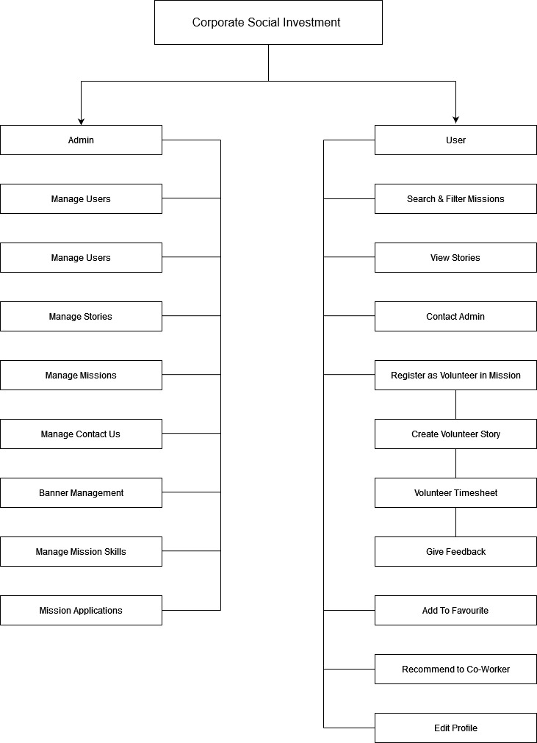

**5. Input/Output Design:**

* Login

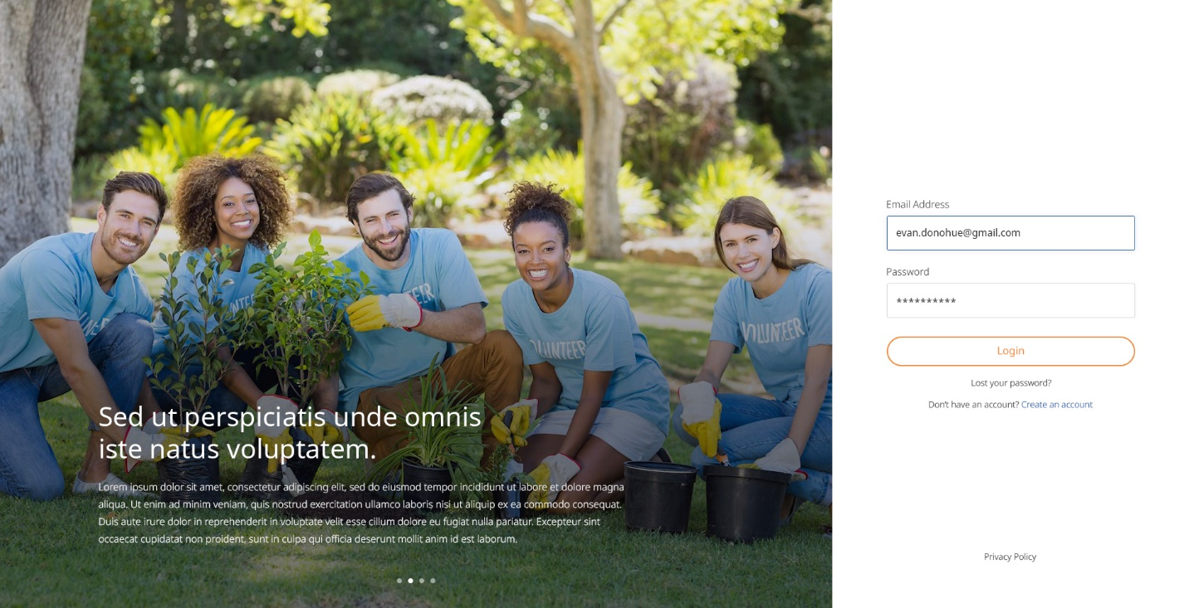

* Forgot Password:

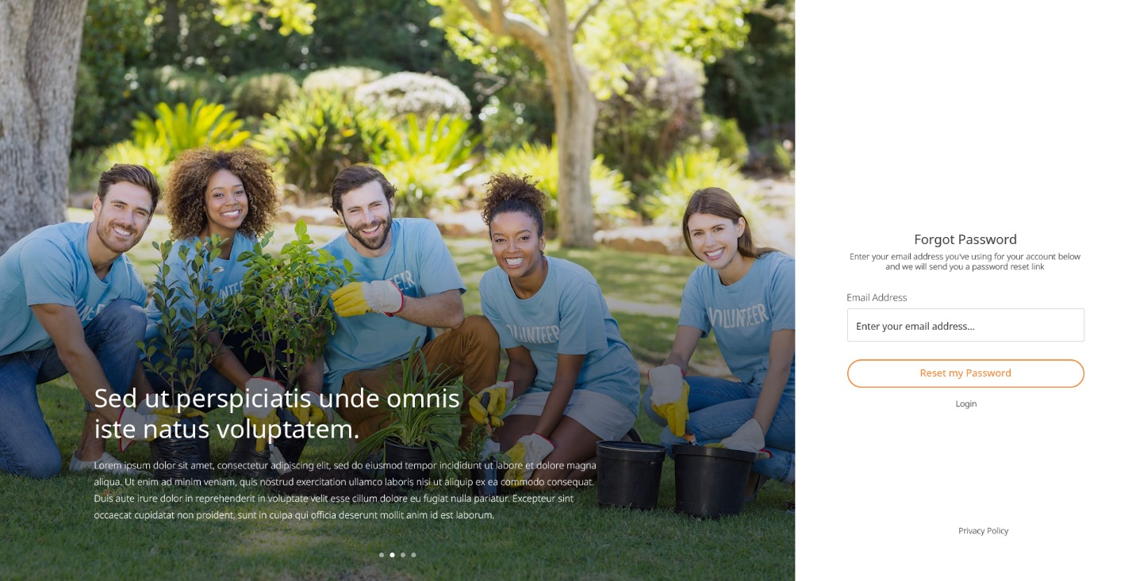

* Reset Password

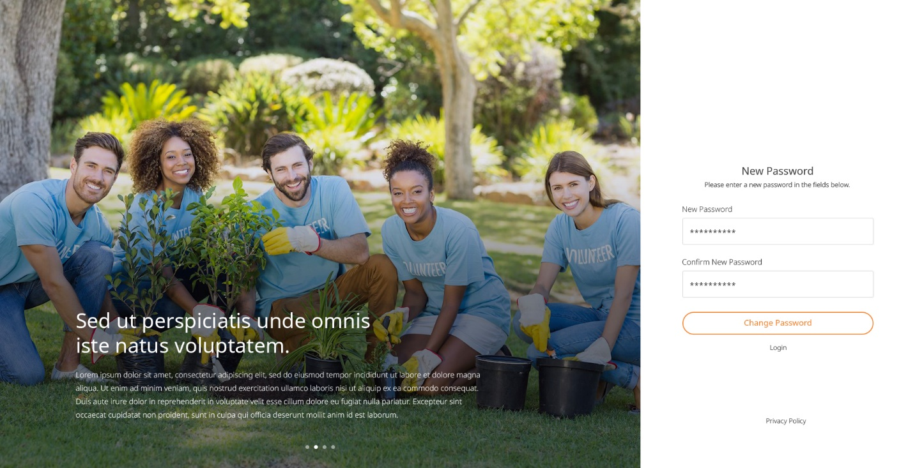

* Registration

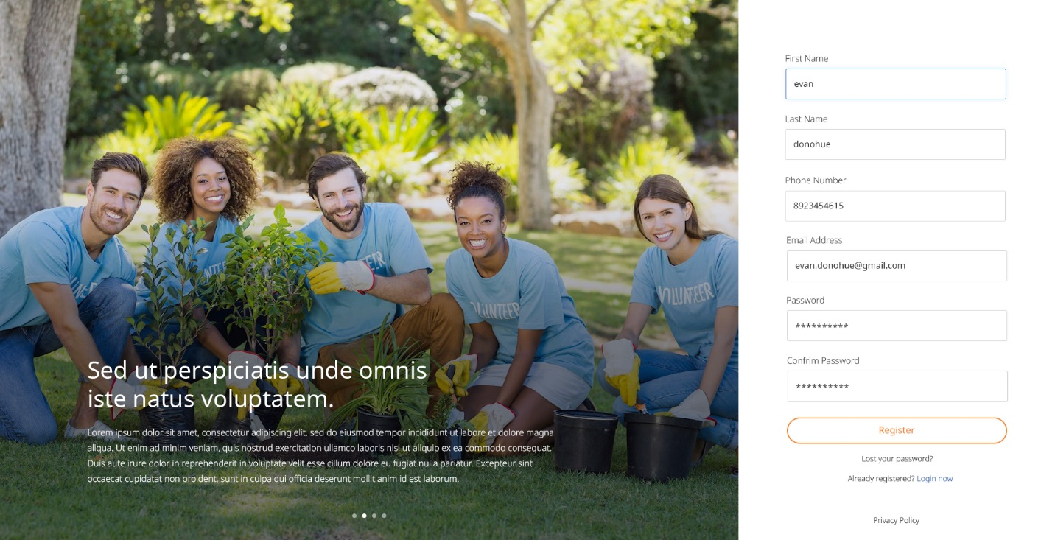

* Platform Landing Page

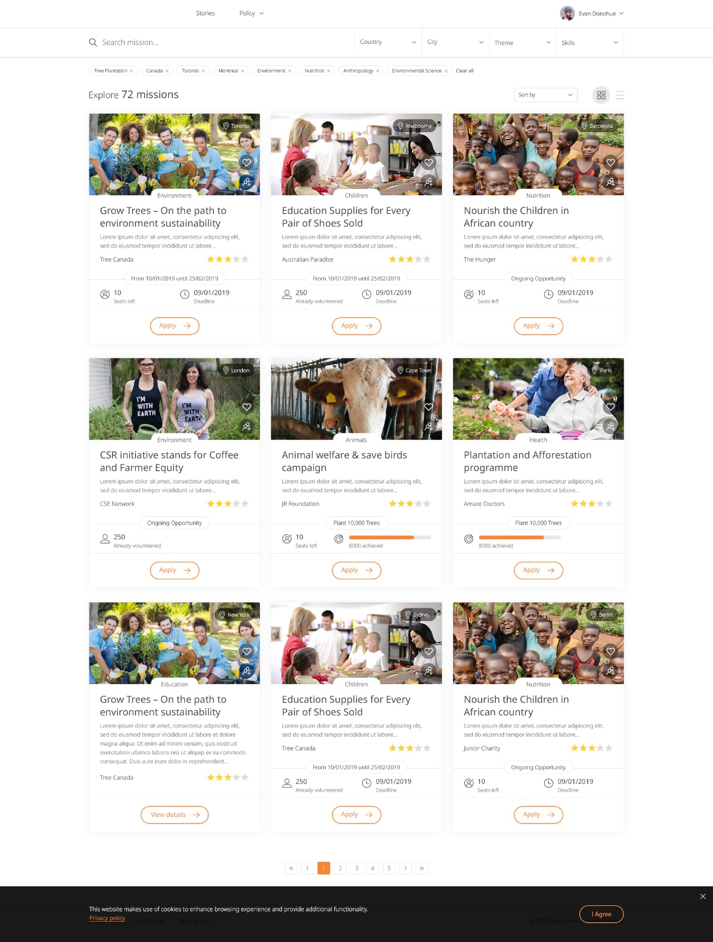

* Mission Grid View

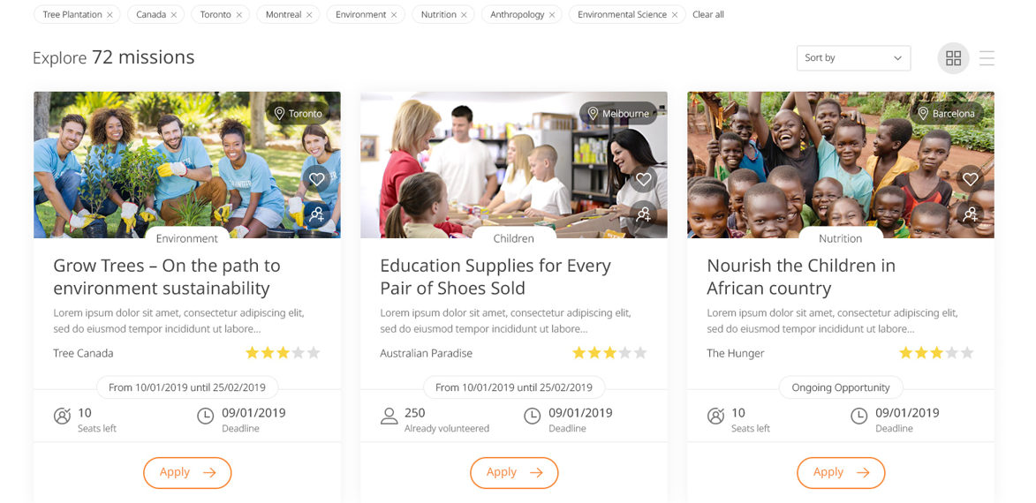

* Mission List View

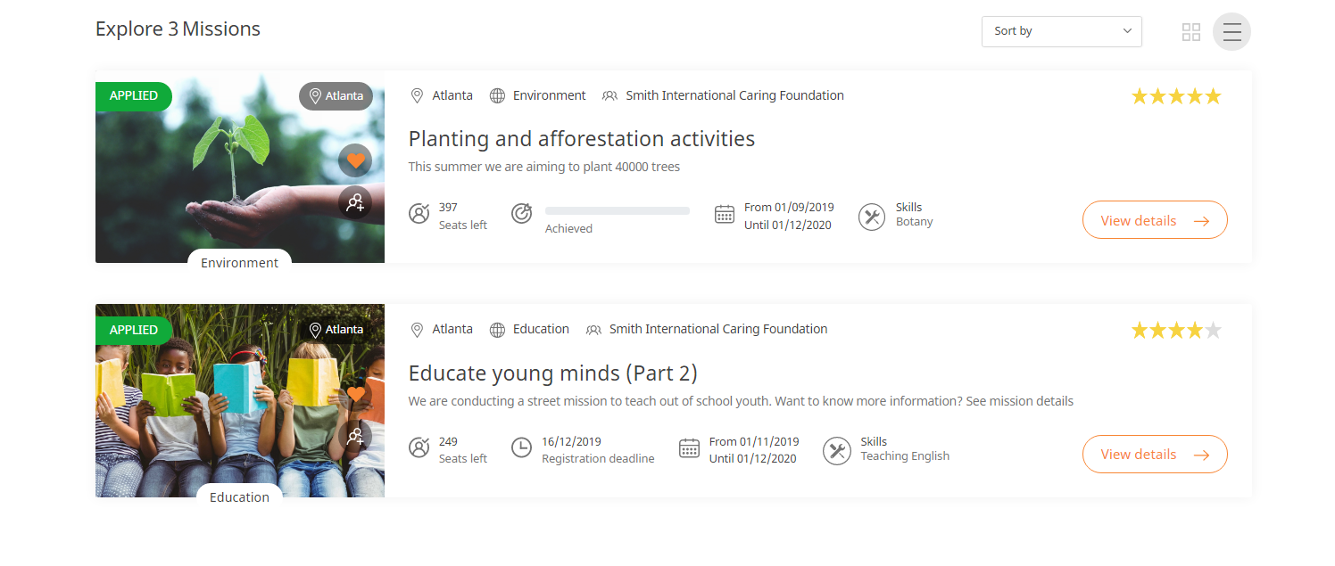

* No search result

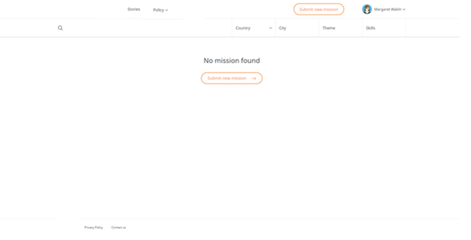

* Mission Page

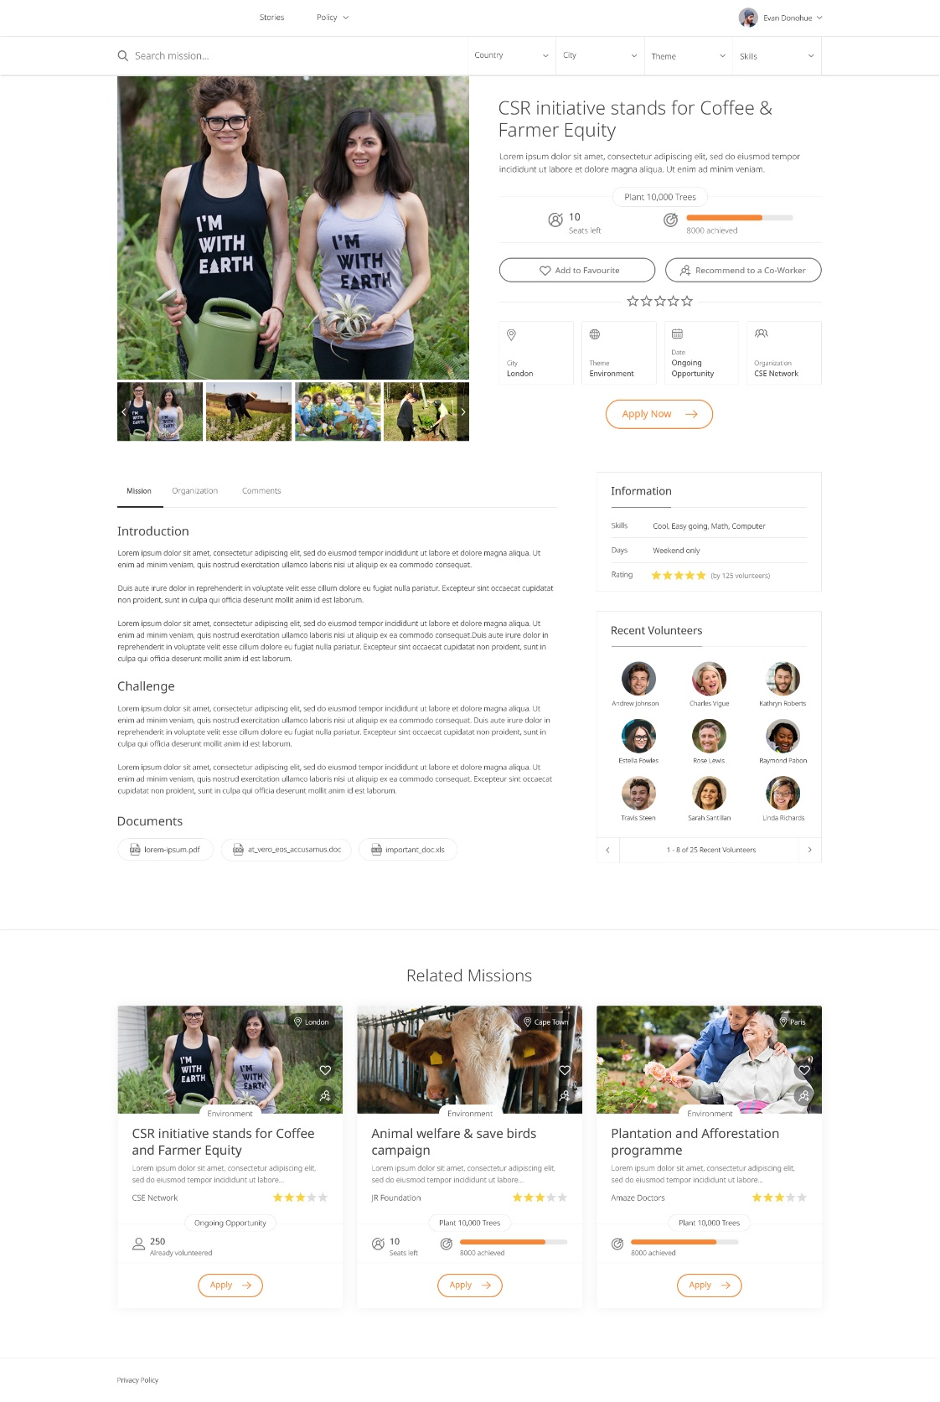

* Story Listing Page

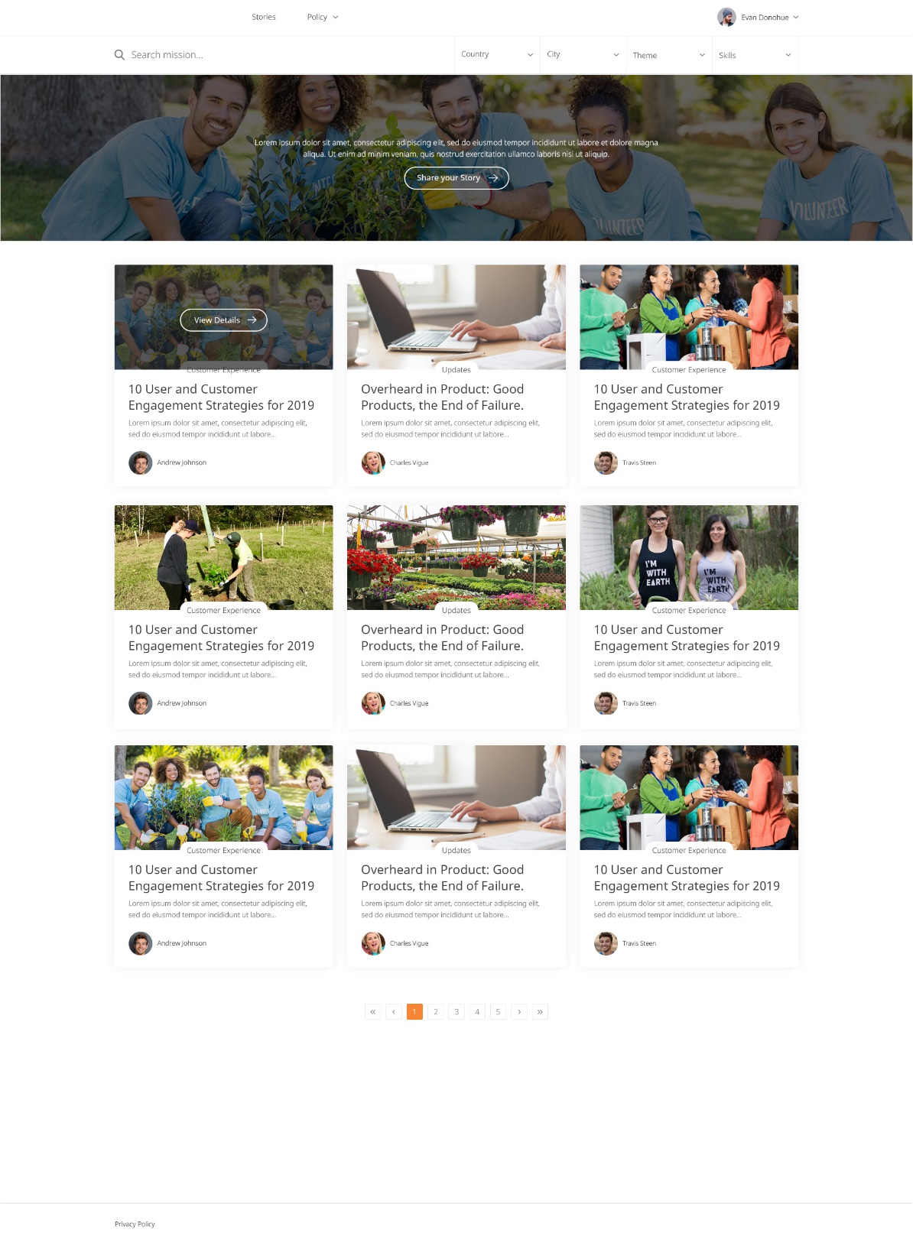

* Share your story(Save/Edit)

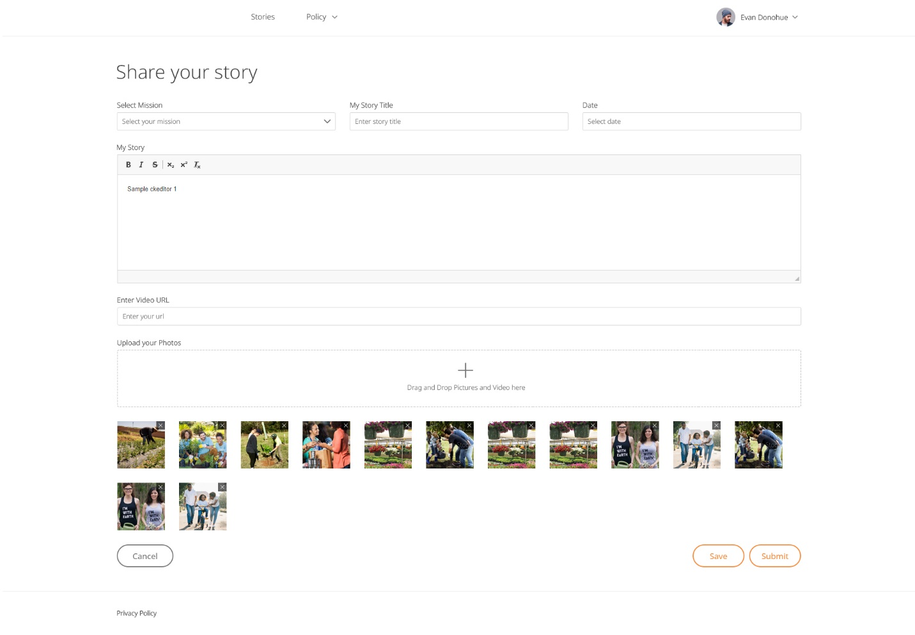

* Story details Page

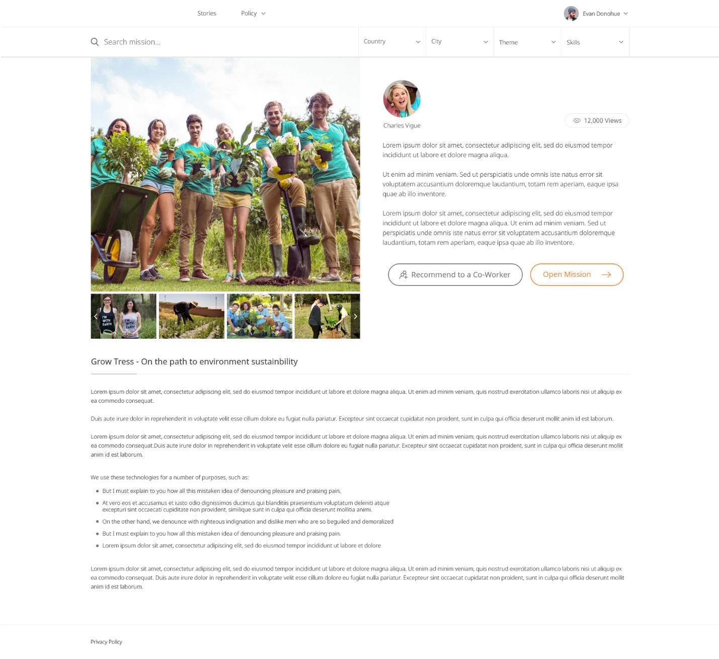

* Volunteer timesheet

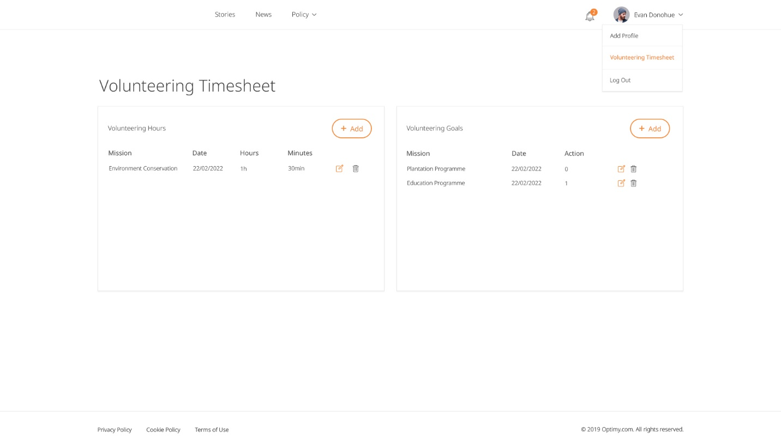

* Volunteer Hours Entry

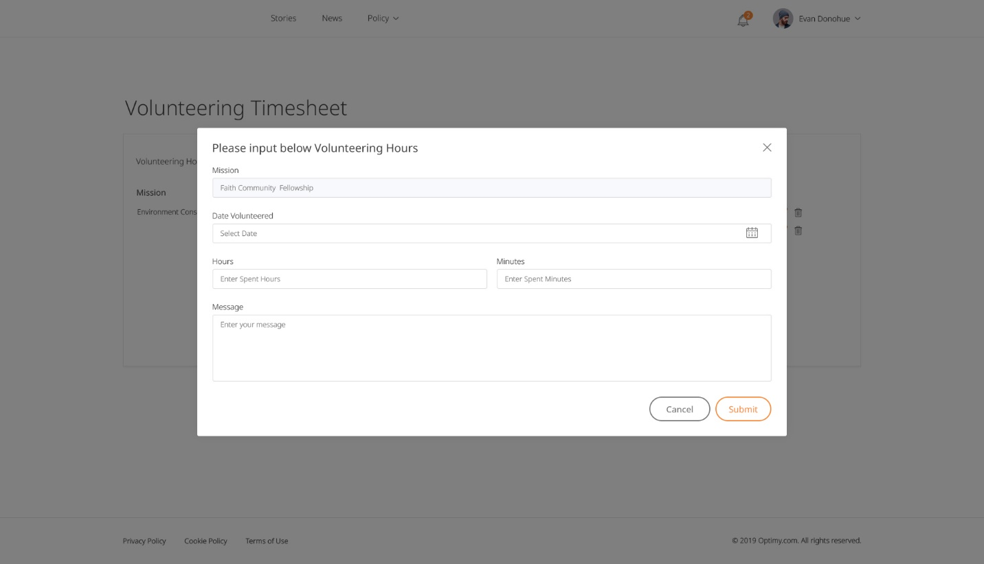

* Volunteer Goals Entry

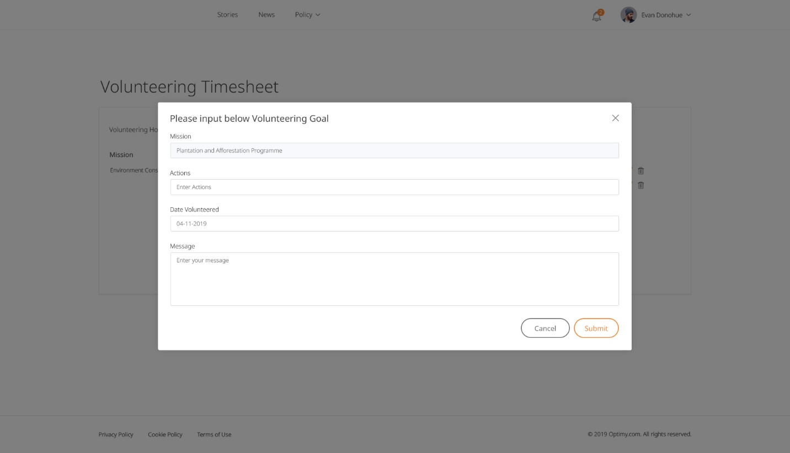

* User edit profile

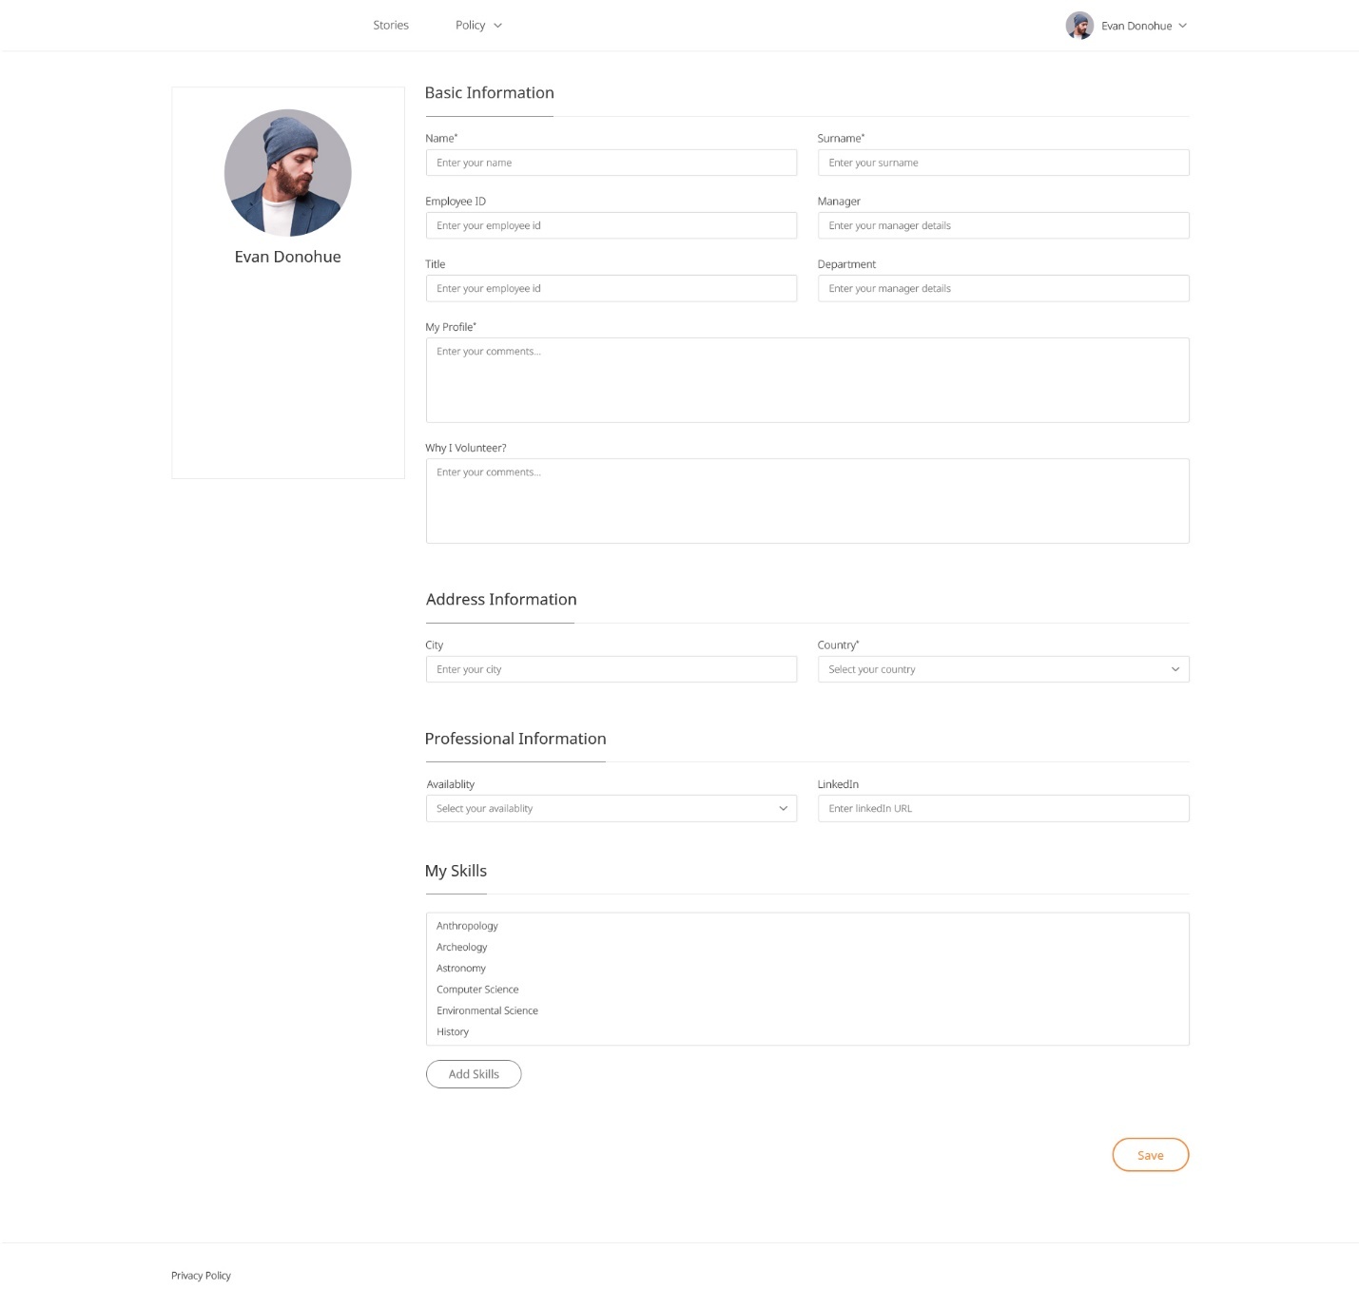

* Change password

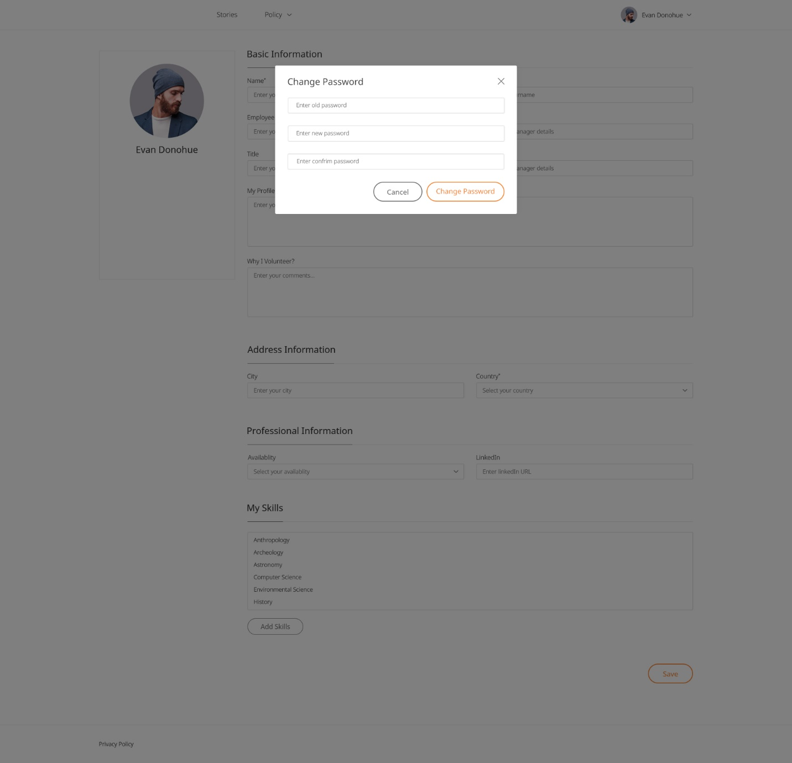

* Add Skills

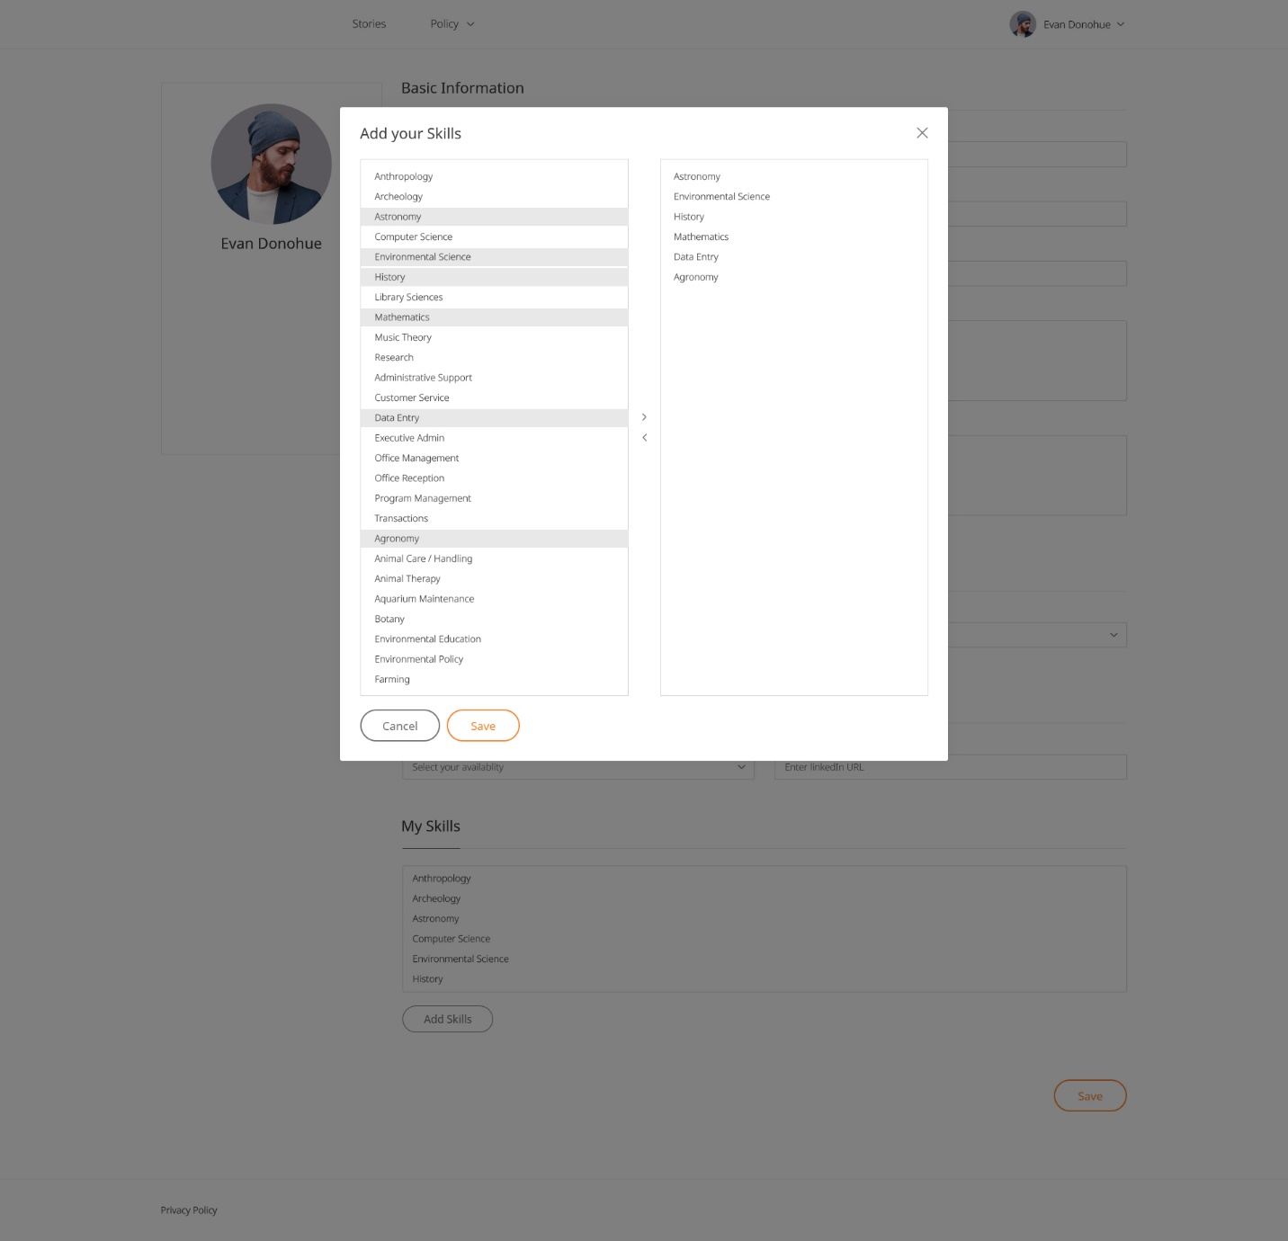

* Contact Us

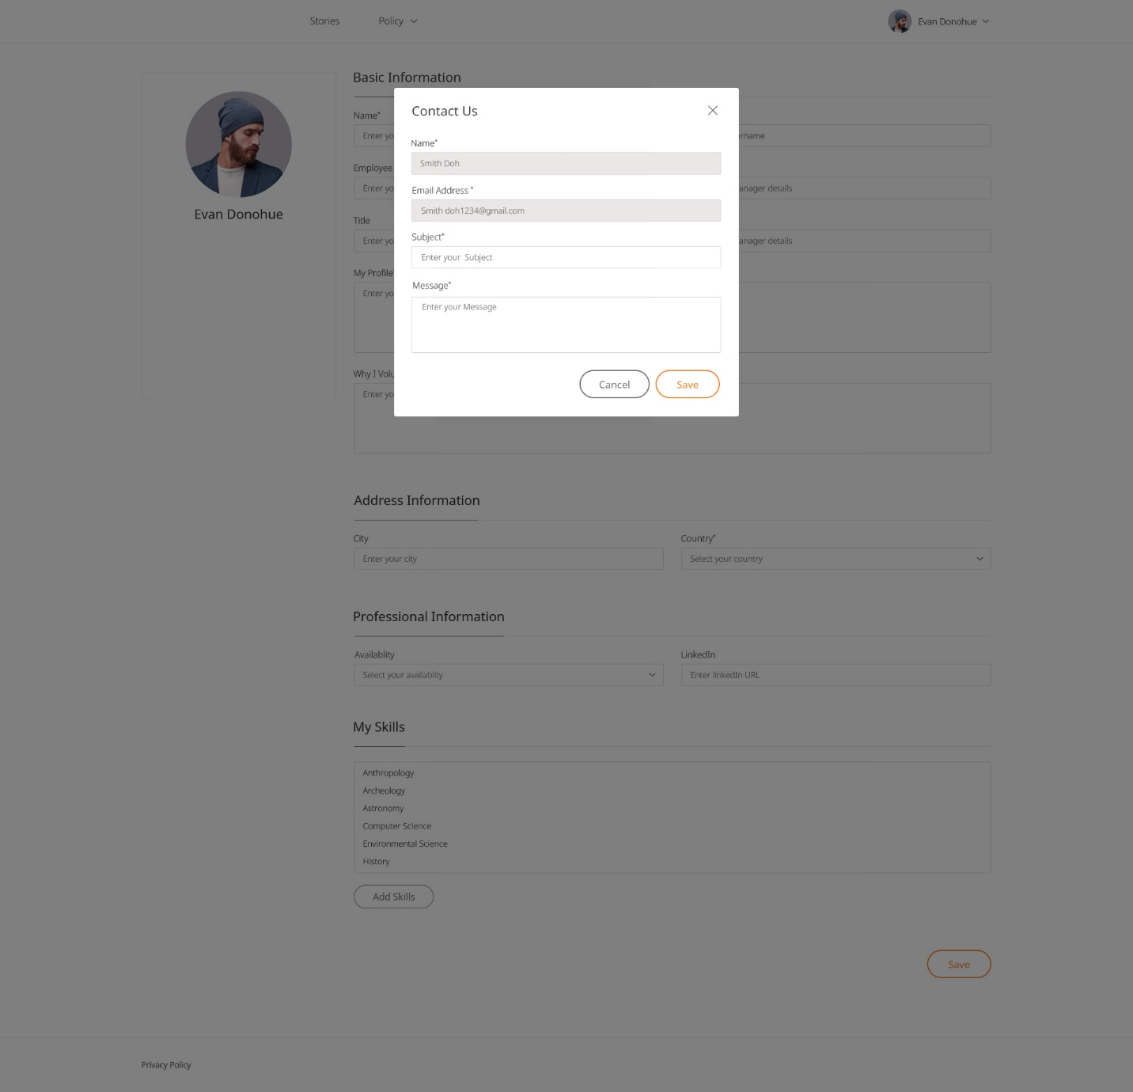

* **Admin**
* User

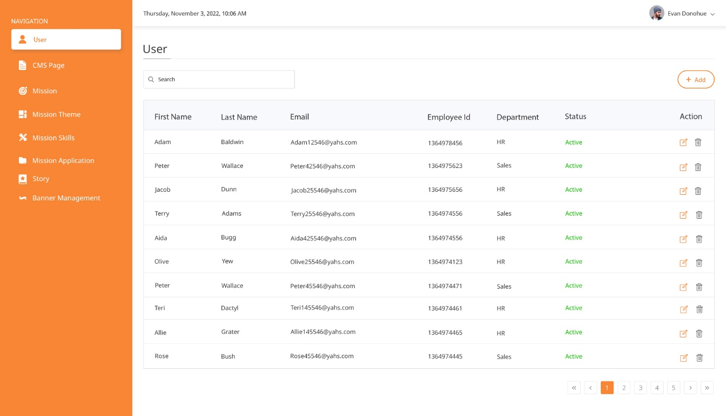

* CMS Pages

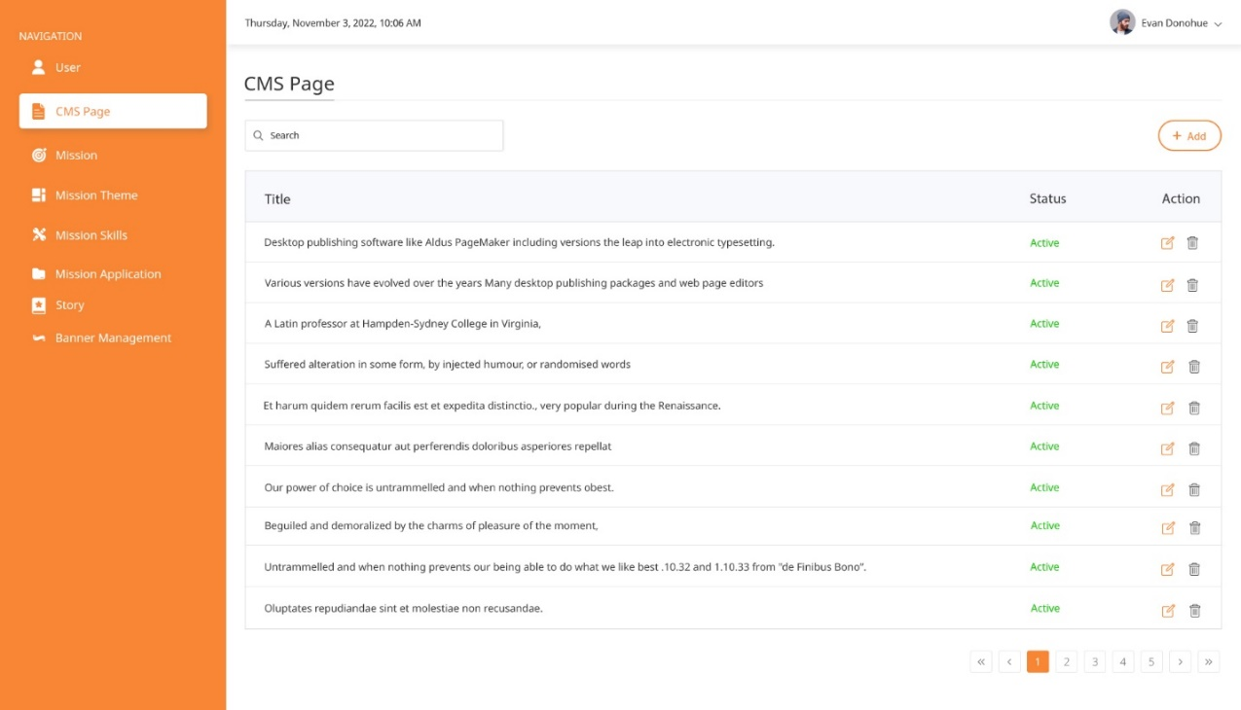

* CMS Pages(Add/Edit)

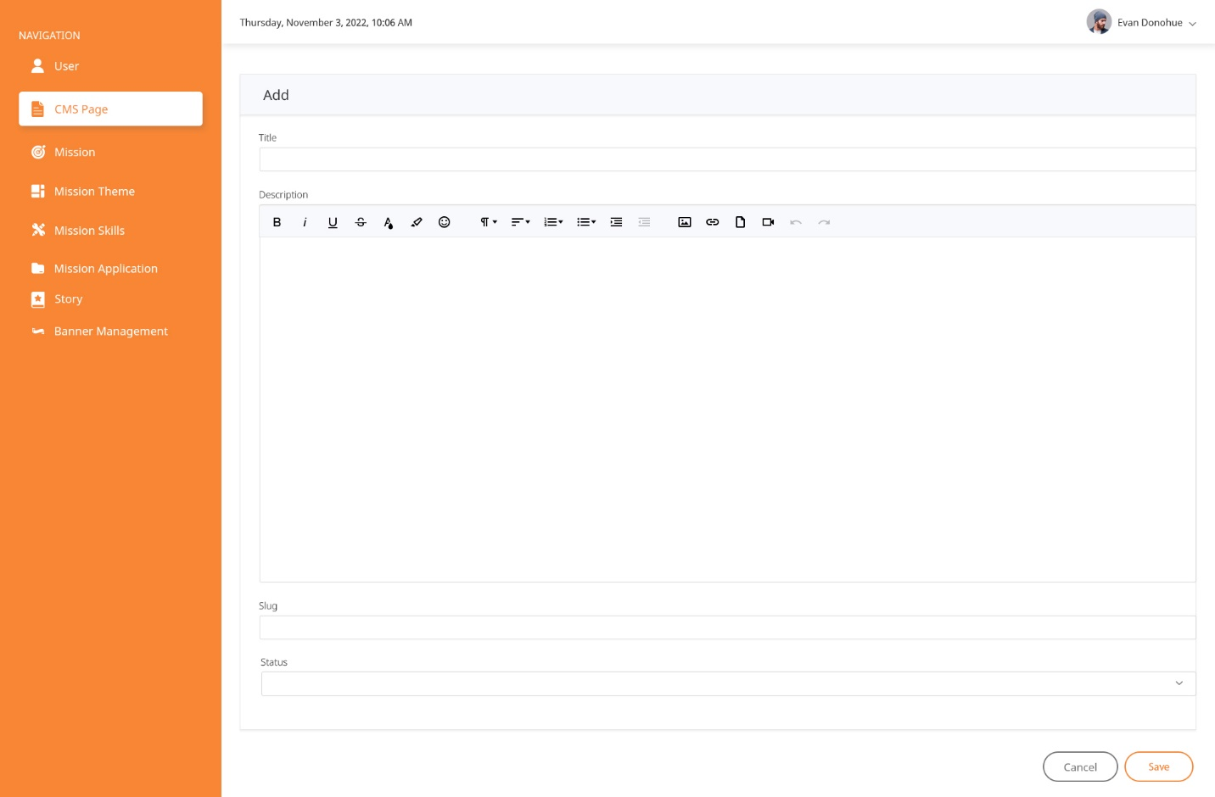

* Missions

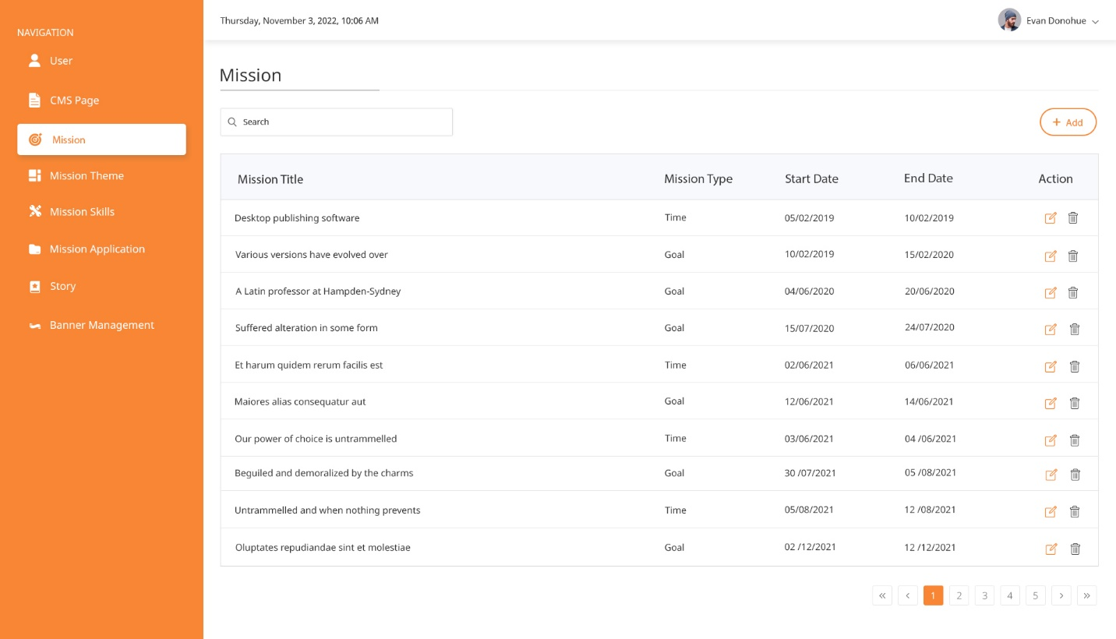

* Mission Application

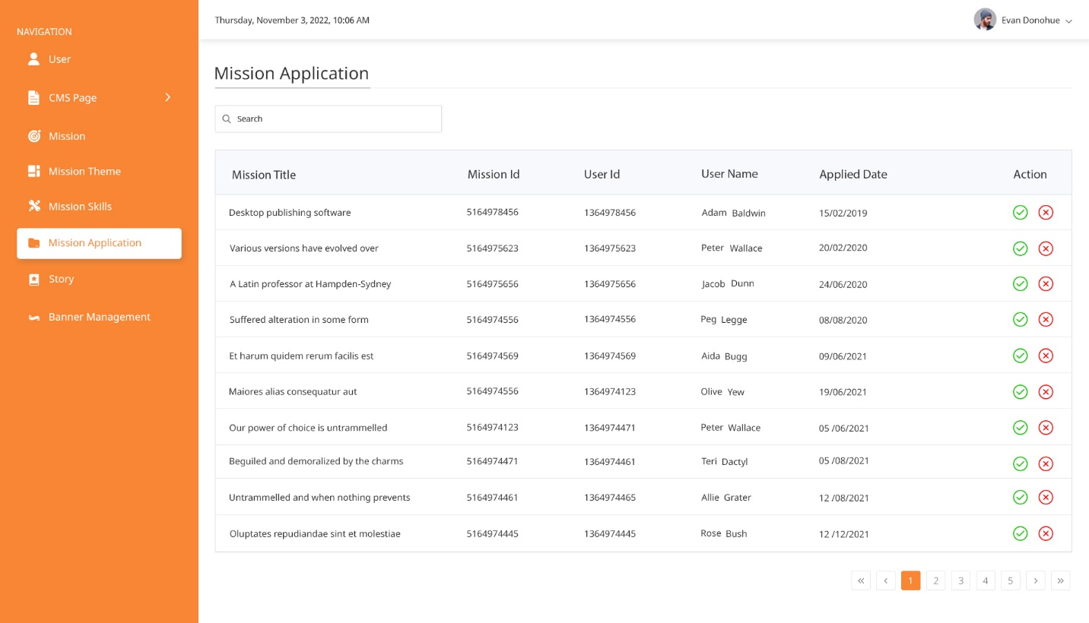

**6. Testing**

* Login

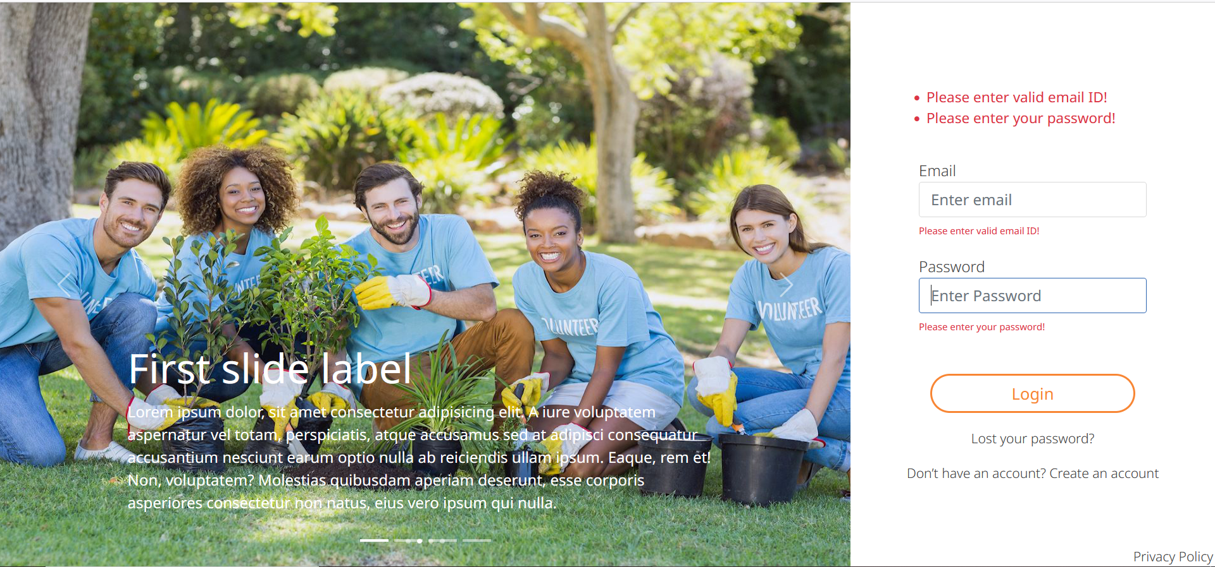

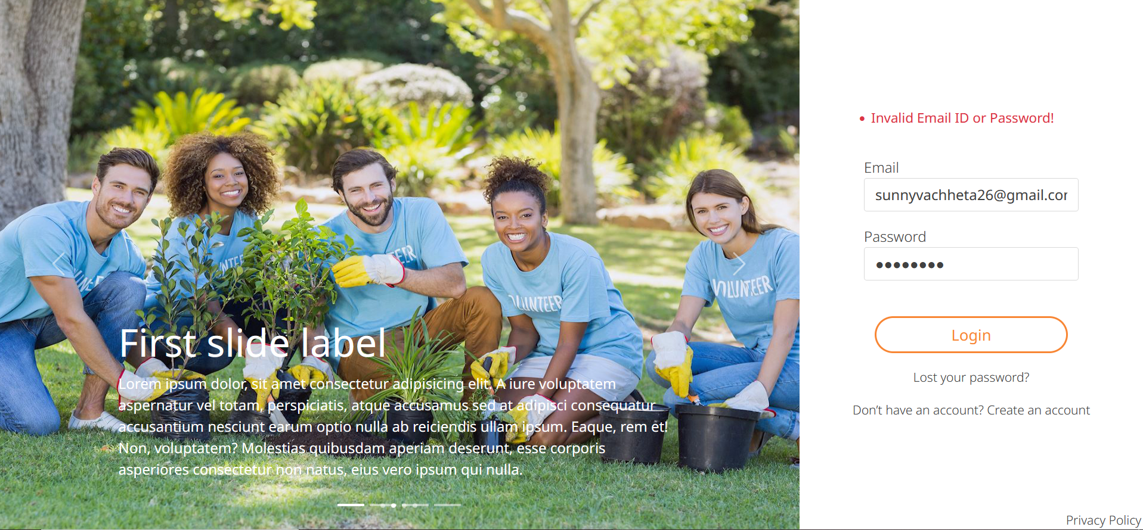

* Registration

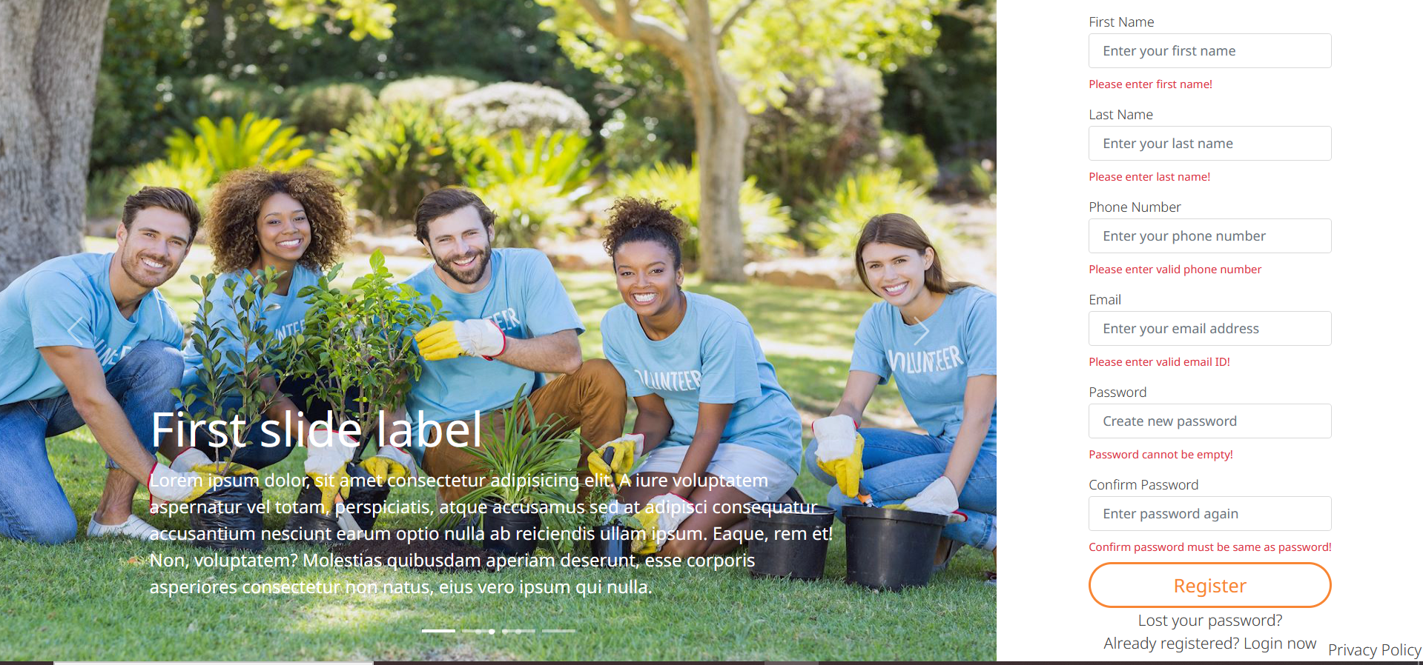

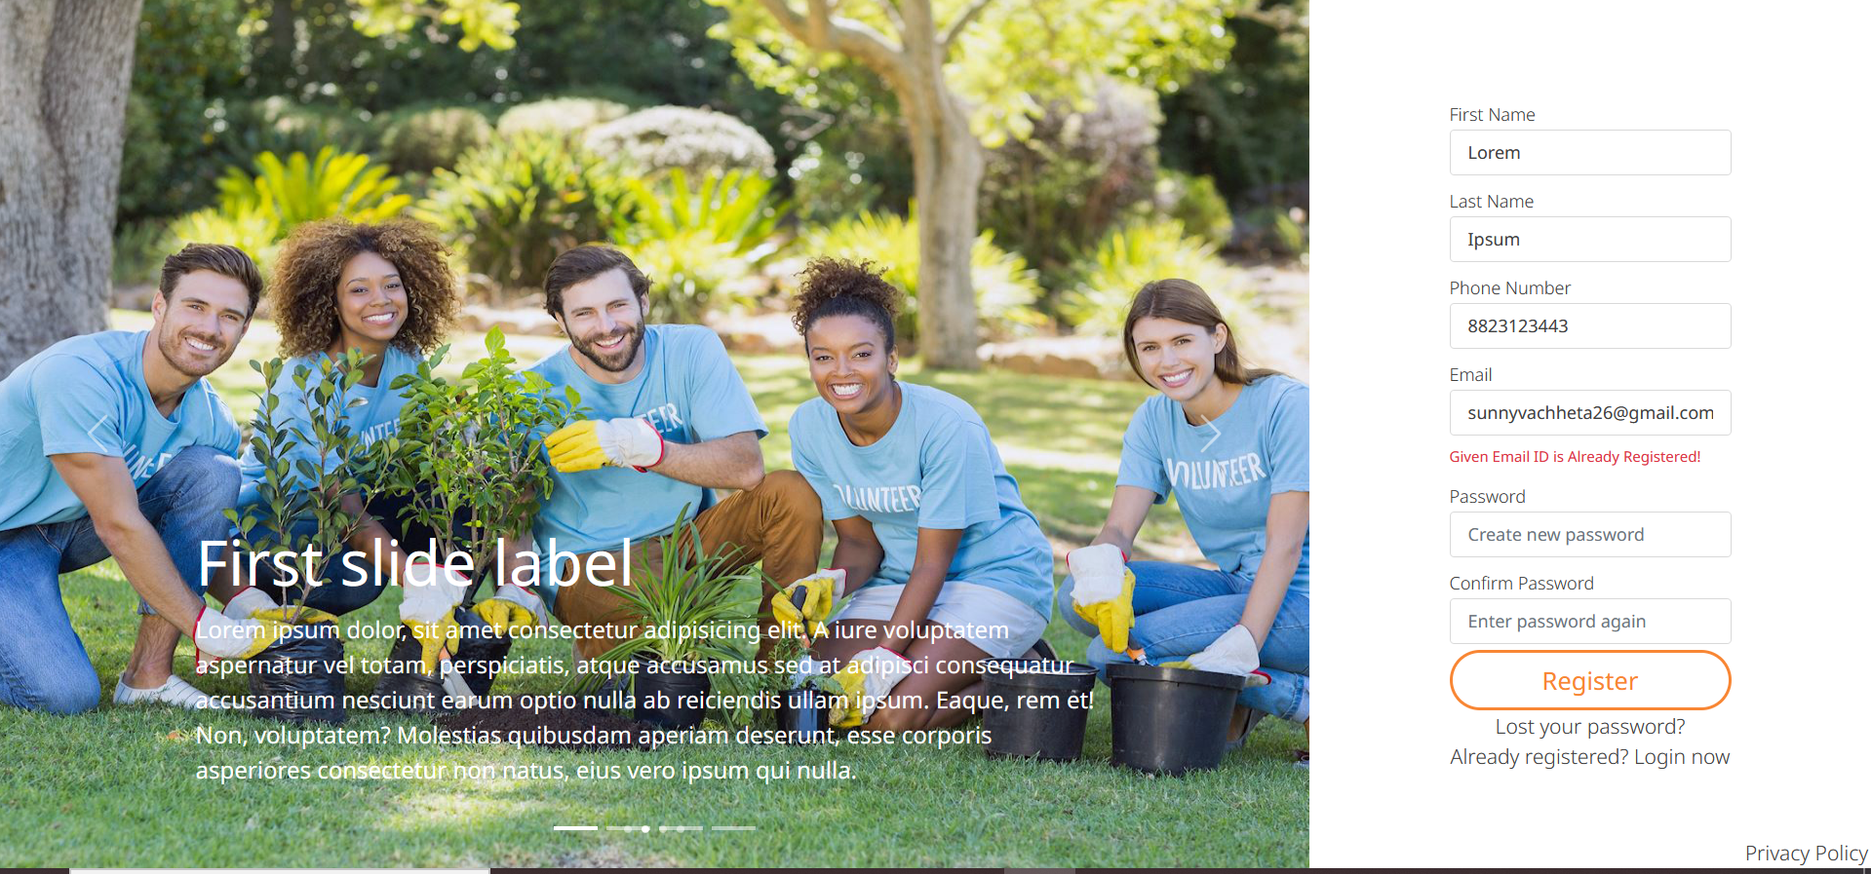

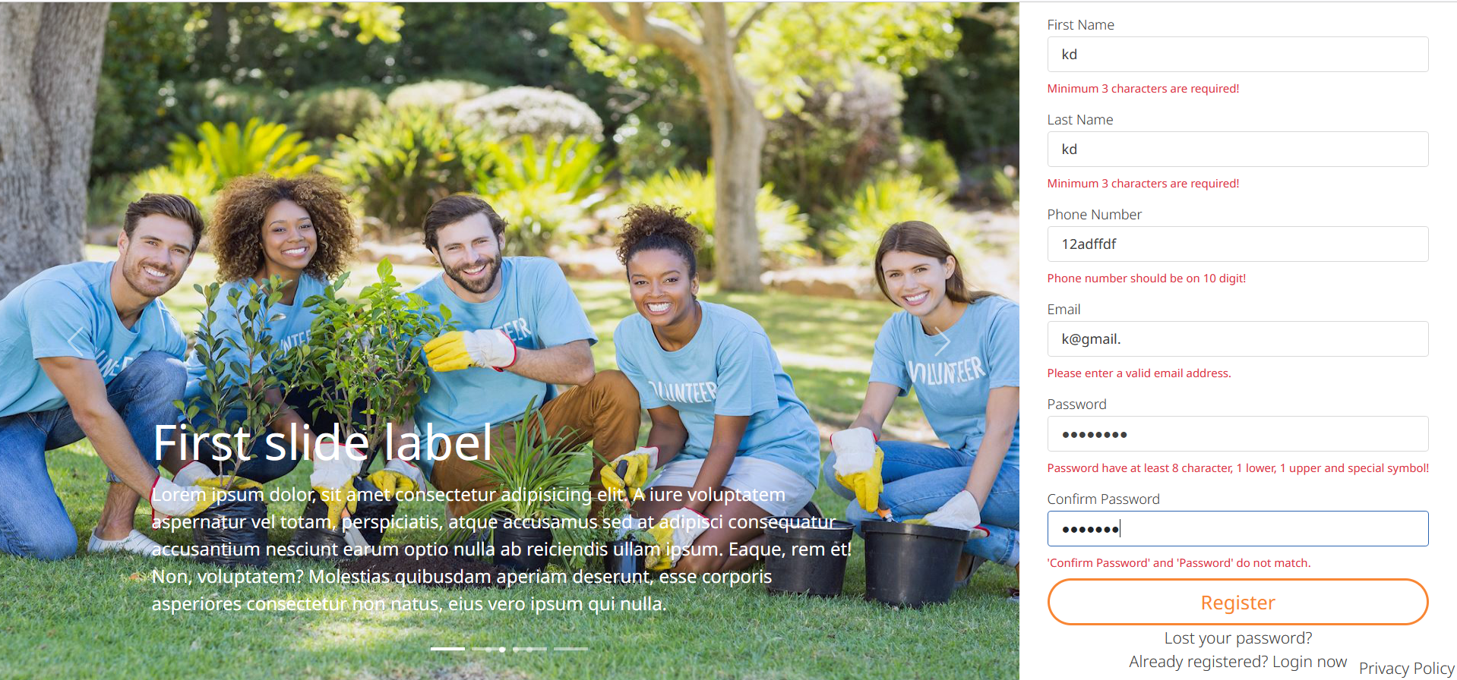

* Forgot Password

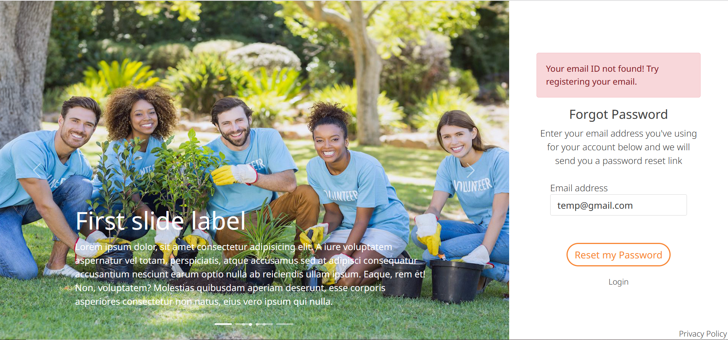

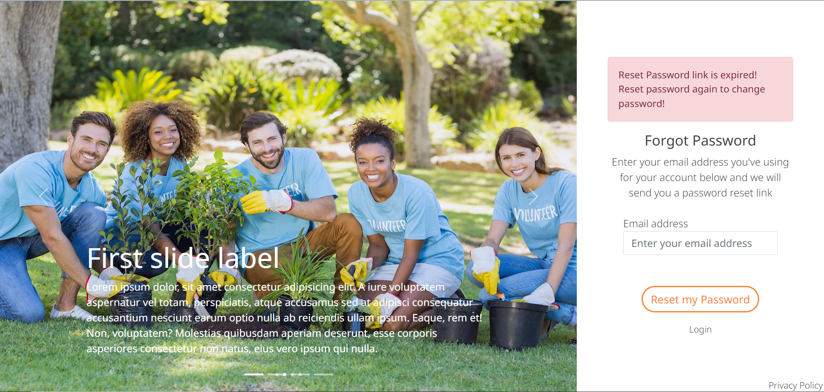

* Add to favourites

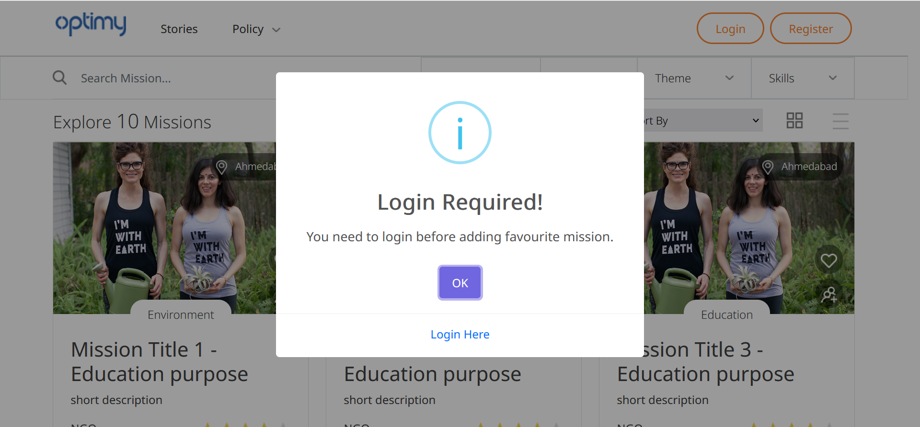

* Star rating

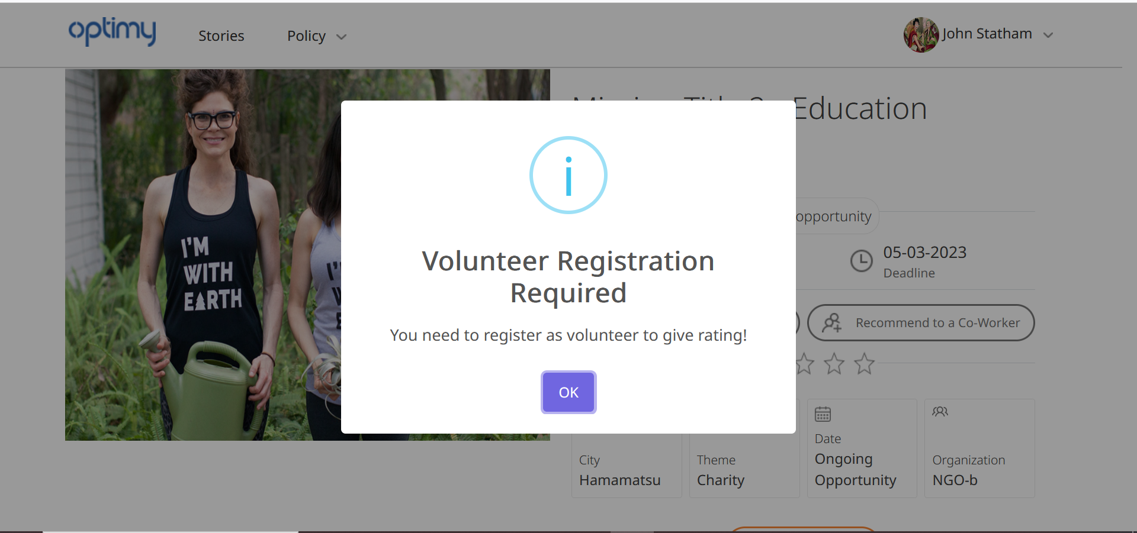

* Add comment

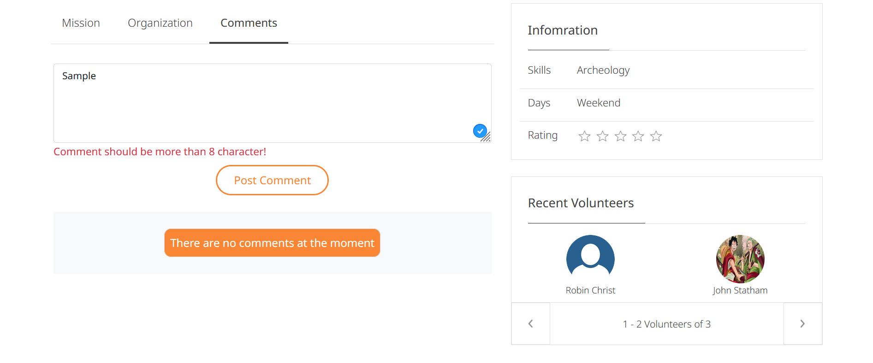

* Add story

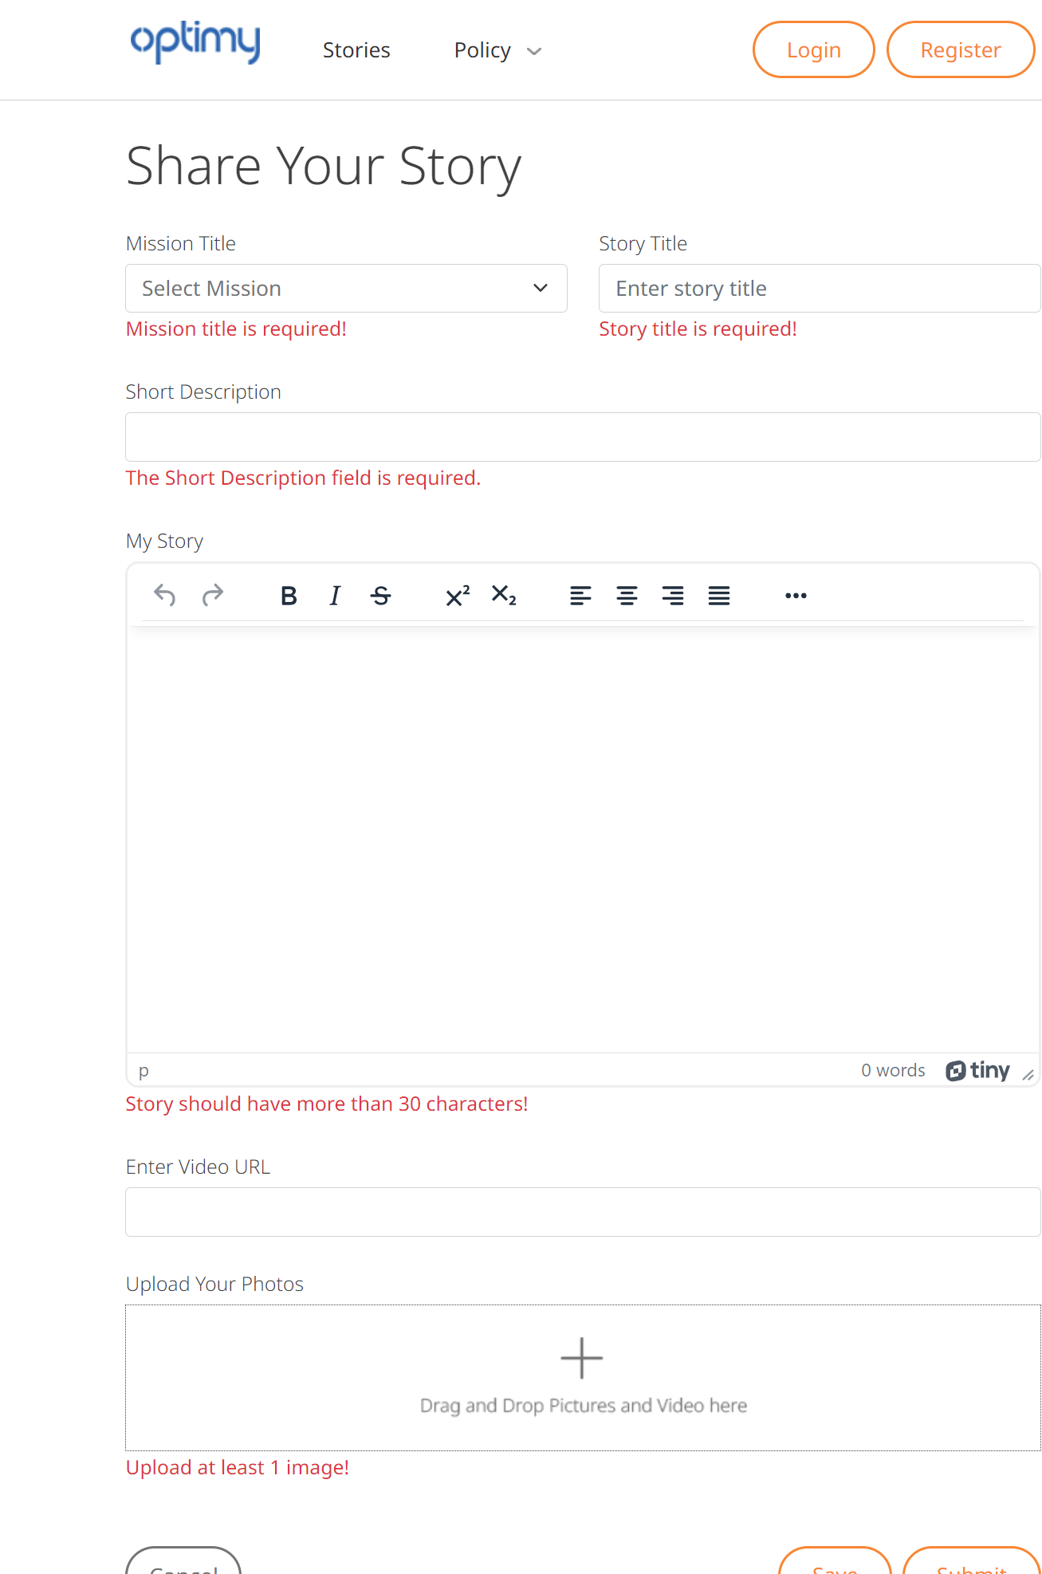

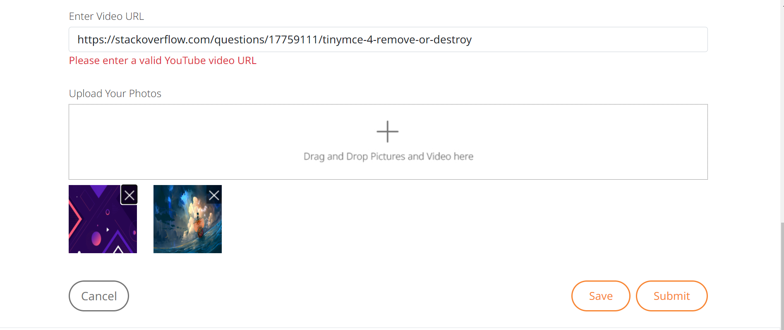

* Timesheet

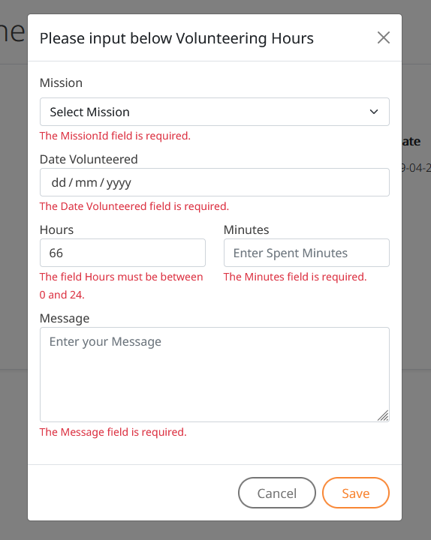

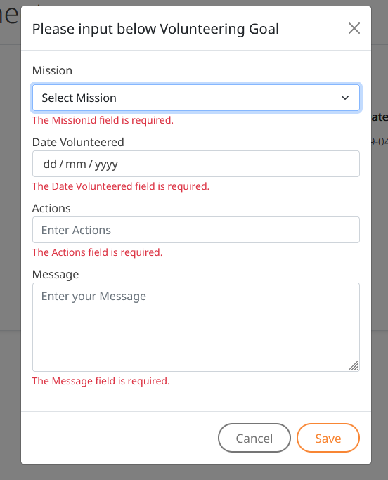

* **Admin**

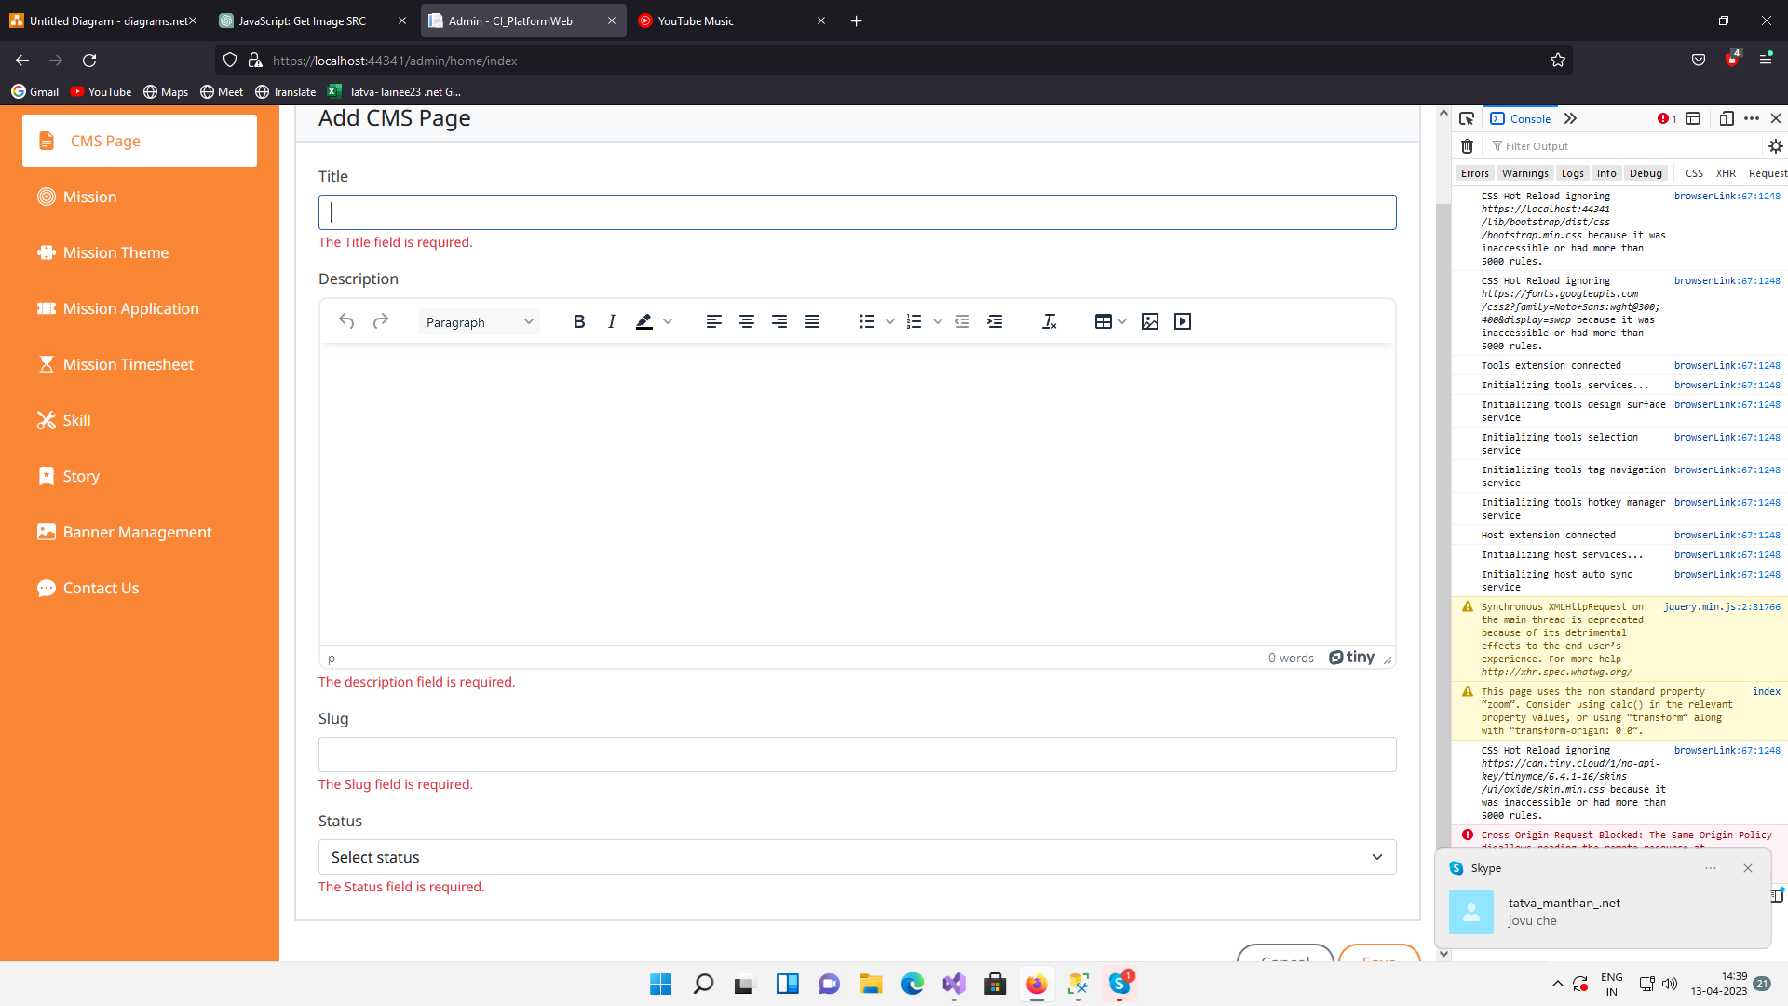

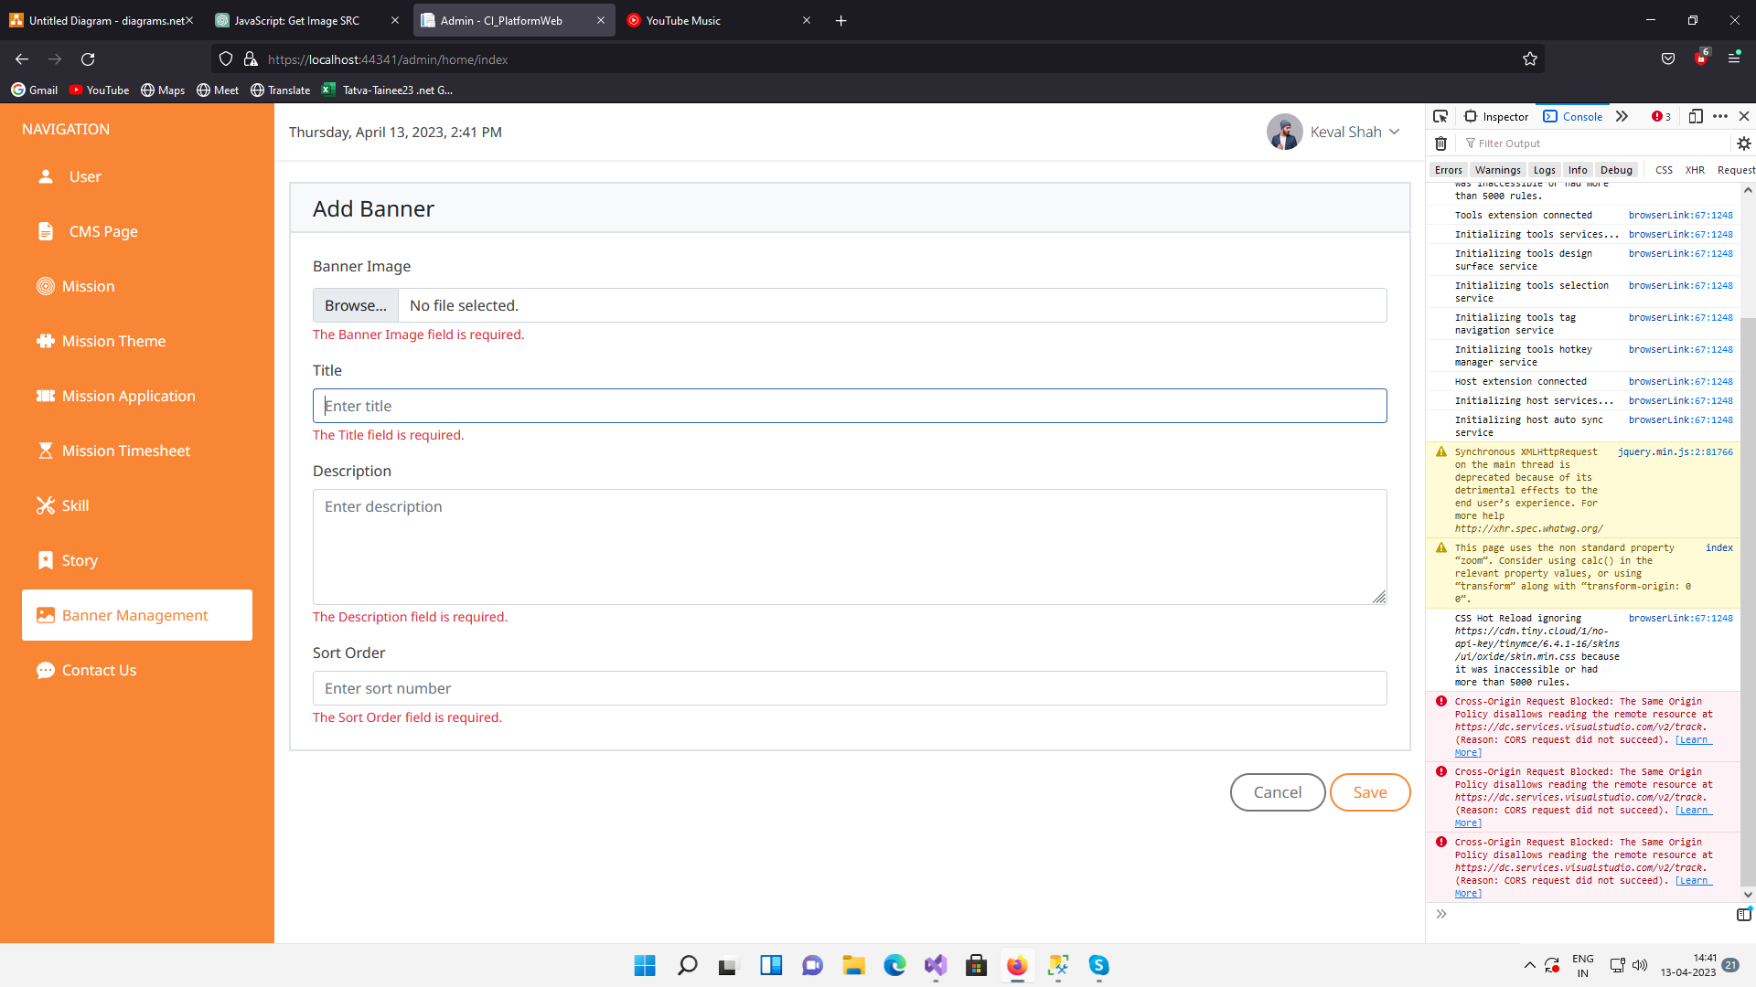

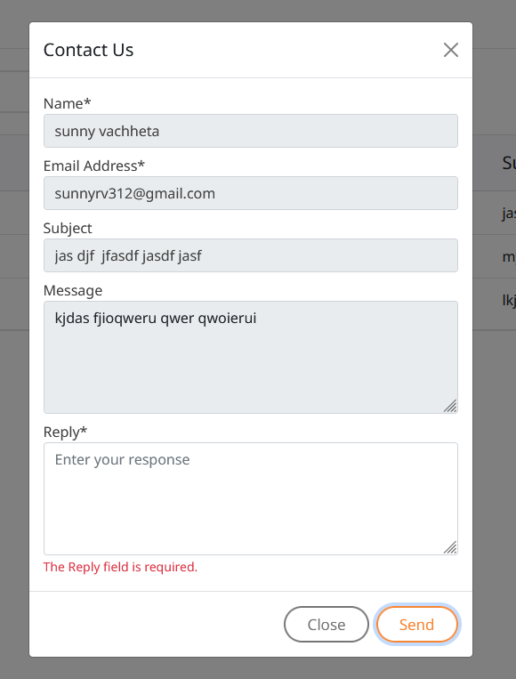

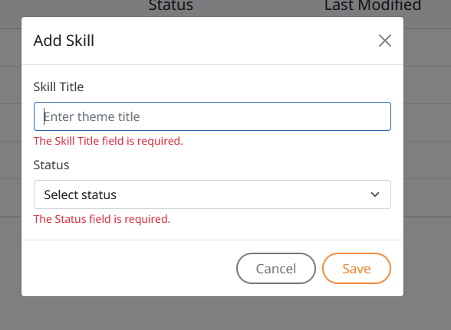

**7. Summary**

**7.1 Assumptions**

* User should remember his/her email ID & password for login.
* Primary knowledge of operating system.
* User should be able to run system properly.
* Admin is using this system for managing various aspects such as users, cms pages, stories, missions, banners, skills etc.

**7.2 Limitations**

* If the user might not able to deal with English language then user might not able to use the system efficiently.
* There can be lack of system security, reliability Community.
* Only Admin can manage this system there is no employee panel.
* Managing users time-sheet manually.
* Authenticity of user entered details.
* Only admin can manage missions.
* No direct communication between NGOs.

**7.3 Future scope:**

* Online donation options on different platform.
* Communication between NGOs and administration.
* Users can submit their ideas for missions and initiatives.

**7.4 Conclusion:**

Main concern for developing Corporate Social Investment platform to streamline the social responsibilities of the company towards the society. This project is proposed to be implementing to replace manual paper work. Encourage employees to engage with society and contribute. Digitizing the process of from volunteer registration to mission end, user management, CMS management and other aspects of system. I know I might have made some mistakes knowingly or unknowingly. But all the suggestions regarding to this system are always welcome.

**Bibliography:**

* <https://developer.mozilla.org/en-US/>
* <https://getbootstrap.com/>
* <https://dotnettutorials.net/lesson/introduction-asp-net-core-mvc/>
* <https://chat.openai.com/>
* <https://stackoverflow.com/>
* <https://www.c-sharpcorner.com/>
* <https://learn.microsoft.com/en-us/aspnet/core/?view=aspnetcore-7.0>
* [Flowchart Maker & Online Diagram Software](https://app.diagrams.net/)